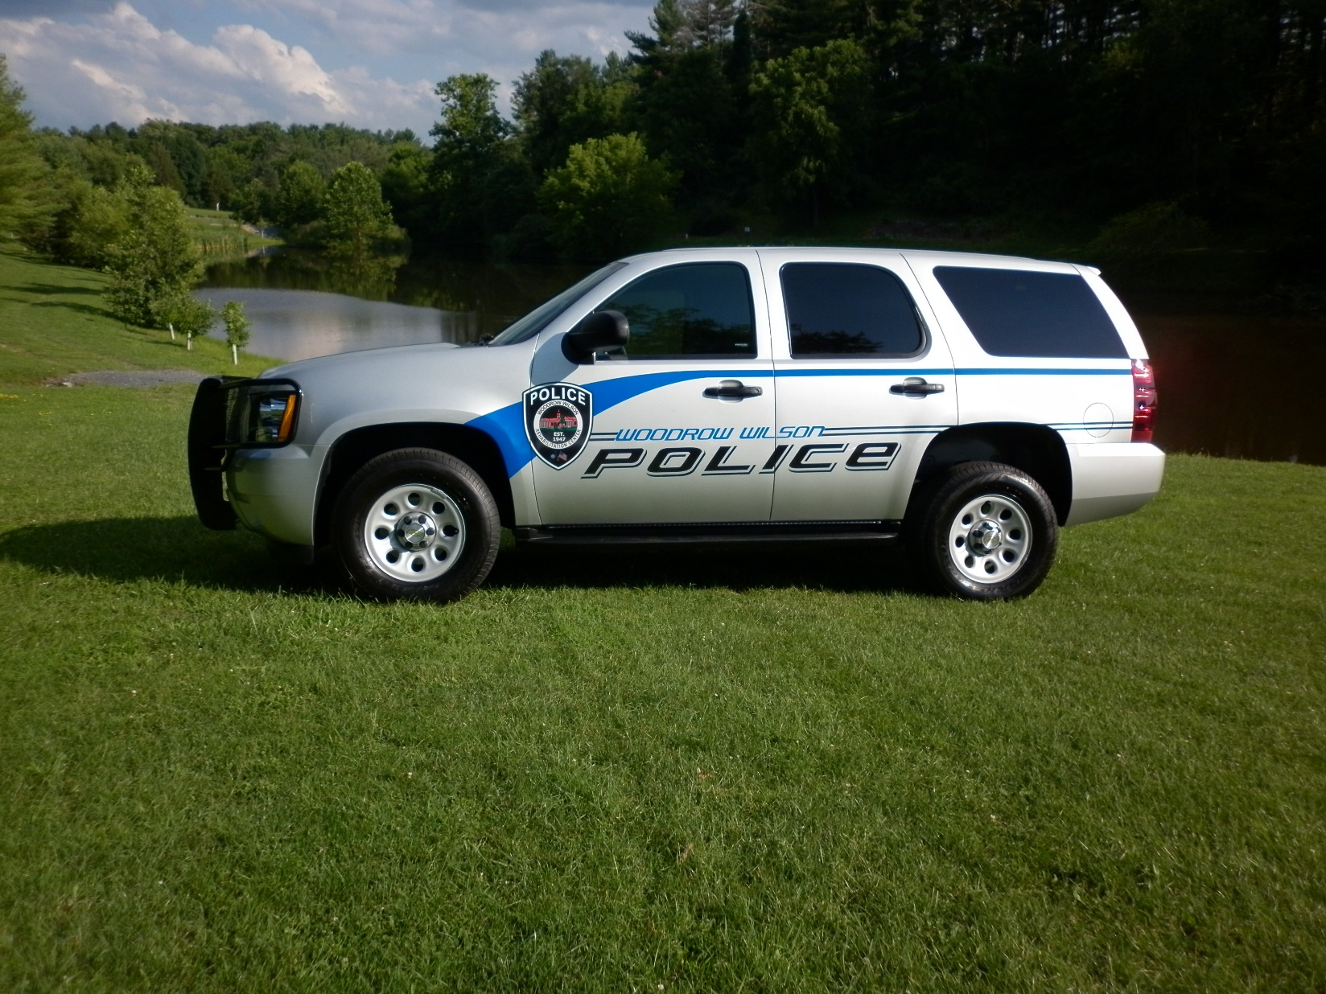

2019

Annual Campus Security Report

The 2019 Campus Security Report was compiled and edited

By

Lt J. Burner

Table of Contents

Introduction

A Legislative History of the Clery Act

WWRC Statement of Purpose

WWRC Police Department

“You’re Right to Know” Statement

Who to Report a Crime To

WWRC Policies and Procedures

* Suspected Sexual Assault Policy
* Harassment Policy
* Reporting Child or Adult Abuse and Neglect Policy
* Reporting of Weapon Inflicted Wounds Policy
* Alcohol and Drug Policy
* Missing Persons Policy
* Serious Incident Review Board
* Search and Seizure
* Elevator Phones: Caller ID System
* Visitation Management Policy
* Threat Assessment Policy
* Work Place Violence
* Crimes of Violence
* Safety and Risk Management
* Emergency Preparedness
* WWRC Emergency Alert System (SARA)
* Emergency Alerts
* Facility Map Identifying Emergency Zones
* Local Agency Emergency and Non Emergency Phone Numbers
* Emergency Alert Procedures

Safety and Security Updates and Accomplishments

Safety Tips

Suggested Web site Resources

**Appendix**

Appendix A – WWRC Criminal Statistics Data Sheet (2016 thru 2018)

Appendix B - WWRC Hate Crimes Statistics Data Sheet (2016 thru 2018)

Community policing involvement

Organizational Chart

Goals & Objectives

The Wilson Workforce & Rehabilitation Center (WWRC) 2019 Annual Campus Security Report is provided in compliance with the 1998 Jeanne Clery Disclosure Act.

This report informs the campus community about important safety and security procedures and policies, crime reporting and prevention, campus crime statistics and useful related resources. A notice shall be provided annually to students and employees advising them that the Campus Security Report and Daily Crime Log may be accessed. Hard copies of the report may be obtained from the WWRC Police Department upon request and may also be viewed on the WWRC Police Department Web site at:

<http://wwrc.virginia.gov/PoliceDepartment.htm>.

.

Prospective employees and students shall also be afforded the same information. Any person(s) may have access to these reports and logs. The Annual Fire Safety Report and Fire Log which is completed by the WWRC Risk Management Department are also accessible, and hard copies are available upon request by contacting the WWRC Risk Management Department at 540-332-7163.

Compilation of information for WWRC Campus Security Report, as well as criminal statistical data as required by the Clery Act is accomplished through cooperative efforts with the following WWRC departments, committees and staff: WWRC Police, Residential Services, Human Resources, Serious Incident Review Board, Recreation Services, Safety & Risk Management, Organizational Development & Quality Assurance Division, Executive Staff and Advisors of student groups and organizations.

Criminal statistics for public property immediately adjacent to and accessible from the WWRC campus are requested from neighboring local law enforcement agencies and the Emergency Communications Center.

The WWRC Administration, police, physicians, nurses, counselors, psychologists, therapists, teachers/instructors, residential & recreational staff encourage victims of criminal offenses to report their circumstance to the WWRC Police. Crimes may be reported to any staff of any department. Staff will then assist you with contacting the Police.

**A Legislative History of the *Clery Act***

The *Student Right to Know and Campus Security Act* (Public Law 101-542) was signed into law by President Bush in 1990 and went into effect on Sept. 1, 1991. Title II of this act is known as the *Crime Awareness and Campus Security Act of 1990*. This act amends the *Higher Education Act of 1965* (HEA) by adding campus crime statistics and reporting provisions for postsecondary institutions. It requires the disclosure of crime statistics for the most recent three years, as well as disclosure of the institution’s current security policies. Institutions are also required to issue timely warnings when necessary. All public and private Title IV eligible institutions must comply with the requirements of this act which is enforced by the U. S. Department of Education (ED). This law was amended when Congress enacted the Campus Sexual Assault Victim’s Bill of Rights as part of the *Higher Education Amendments of 1992* {Public Law 102-325, Section 486(C)}, giving victims of sexual assault on campus certain basic rights. In addition, institutions are required to develop and distribute a policy statement concerning their campus sexual assault programs targeting the prevention of sex offenses. This statement must also address the procedures to be followed if a sex offense occurs. The most recent version of this law was passed as part of the *Higher Education Amendments Act of1998* {Section 486(e) of Public Law 105-244}. The official title under this act is the *Jeanne Clery* *Disclosure of Campus Security Policy and Campus Crime Statistics Act* {20 U.S.C. 1092(f)}. On Nov. 1, 1999, ED issued the final regulations which went into effect on July 1, 2000. The amendments require ED to collect, analyze, and report to Congress on the incidences of crime on college campuses. The amendments also expand the requirement of the *Student Right to Know and Campus Security Act of 1990* that all institutions of higher education participating in the federal student aid programs must disclose to students, faculty, staff, and, upon request, prospective students information regarding the incidence of crimes on campus as part of their campus security report. The 1998 amendments made several changes to the disclosure requirements. Among these changes were the addition of two crimes (Arson and Negligent Manslaughter) and three locations (residence halls, non-campus buildings or property not geographically contiguous to the campus, and public property immediately adjacent to a facility that is owned or operated by the institution for education purposes) that schools must include in the reported statistics. Institutions that have a campus police or security department are required to maintain a daily crime log that is available to the public. The *Clery Act* was further amended in October 2000 by the *Campus Sex Crimes Prevention Act* (Section 1601 of Public Law 106-386). The changes went into effect on Oct. 28, 2002. Beginning in 2003, institutions are required to notify the campus community where law enforcement agency information provided by a state concerning registered sex offenders who are on campus may be obtained. The text for the regulations, as well as Section 668.41, Reporting and Disclosure of Information, are included in this appendix.

## Wilson Workforce & Rehabilitation Center Statement of Purpose

It is essential for Wilson Workforce & Rehabilitation Center to maintain an environment in which there exists a positive atmosphere of well being. Employees, clients and visitors to the Center must perceive themselves as being well protected, well cared for, and secure in their environment. Only when this perception is established can the Center’s primary missions of learning, teaching, and rehabilitation be achieved.

*The primary purpose of this WWRC Police Department is to support the rehabilitation process through the maintenance of a peaceful and orderly community and through the provision of general and emergency services. The accomplishment of this purpose will be fulfilled through constant attention to the areas of public safety, security, law enforcement, and service assistance to the various departments, offices and staff at WWRC.*

*The department’s public safety role ensures that community members enjoy the same degree of protection from personal harm and a high degree of security for their property. This protection is manifested in round-the-clock patrol of the Center campus, crime prevention, personal safety awareness programs, and constant attention to the correction of potentially hazardous conditions.*

*With regard to security, the department’s major emphasis rests with the campus physical facilities and the property within them. By patrolling both the interior and exterior of the facility, the maximum protection necessary for each building will be maintained. The operating condition of all locks and security hardware is noted and referred for repair as needed.*

*In fulfilling its law enforcement responsibilities, the department strives to insure that the peace and order of the rehabilitation center and environs are maintained at all times. Through enforcement of the Center’s rules, regulations, and policies, as well as the state laws, the department protects the community from the unlawful, dangerous, or negative acts of any individual or group. The prevention of such acts, or the apprehension and adjudication of persons committing them, serves to maintain the desired residential setting necessary for a state rehabilitation facility.*

*An important facet of the department’s overall purpose is in the area of service to the community. Not only does this include emergency services, but general services as well. This service function also extends to the assistance of, and cooperative efforts with, the various administrative; training; residential and therapy departments at the Center. All the various departments are striving toward one main goal that of a thriving and successful rehabilitation center, and the many programs and projects necessary for reaching this goal must be cooperative ventures. The WWRC Police Department places a high degree of priority on cooperation with the various departments within the Center. Assistance to the different departments serves as added support for the Center as a whole, as well as a viable means for interaction with all segments of the community. Existing lines of communication should constantly be strengthened and new ones created.*

*In fulfilling the responsibilities associated with its purpose, the WWRC Police Department recognizes and respects the mission of the Virginia Department of Rehabilitative Services and of Woodrow Wilson Rehabilitation Center and strives to play an integral role in that mission. The department’s concern for the well being of the community, desire to provide service and assistance whenever possible, and dedication to supporting the rehabilitation environment are all factors that are inherent in the department’s daily operations and policies.*

**Woodrow Wilson Rehabilitation Center**

**Police Department**

The WWRC Police Department is a full service sworn law enforcement agency devoted to the welfare of the WWRC campus and its students, staff, visitors and the local community. The Department enforces state laws, local ordinances and the WWRC policies, rules and regulations on all property owned or controlled by the agency, as well as on adjacent streets and sidewalks. The department has good working relationships with neighboring agencies and responds to calls within their jurisdictions as requested and authorized. The WWRC Police Department consists of sworn Police officers certified by the Virginia Department of Criminal Justice Services as well as civilian staff (Administrative).

**The WWRC Police Department performs various functions in order to maintain a safe and secure campus for its students, staff and visitors:**

**Patrol:**  Patrol is a key component of crime prevention and maintaining a safe andsecure environment. Patrols of the campus are routinely made on each shift, 7 days a week, 365 days a year. Checks are made on the interior and exterior of all buildings as well as the interior and exterior perimeters of the campus. Patrols include traditional foot patrol, bicycle and vehicular patrol. Our officers respond to all emergencies whether it is police, fire or medical in nature.

**Investigations:**  WWRC Officers conduct investigations when crimes occur on the WWRC campus, as well as conducting investigations of violations of the agency’s policies, rules and regulations. Our department works closely with the local Commonwealth’s Attorney’s Office and court systems when necessary to prepare cases for possible trial.

**Traffic Enforcement:**  The WWRC campus is located in a complex adjacent to various other educational facilities and is surrounded by main routes of traffic in and out of the complex. Therefore, in order to maintain a safe environment, our Officers routinely monitor traffic and strictly enforce the traffic laws in accordance with the Code of Virginia. As always, the safety of our students, staff and visitors is of utmost importance.

**Resource/Support:** While patrolling, Investigations and enforcing traffic laws are some of our main duties, being a resource a source of support to our community are also key functions in crime prevention and providing a safe and secure environment. Our officers are available to provide information or assist in providing education programs on thecampus. We strongly encourage community involvement and education, and are willing to assist in any way we can.

**Reporting Crimes and Police Assistance**

The reporting of crimes is vital in achieving the goal of providing a safe learning environment for the campus community. All persons who are victims or witnesses of a crime should promptly report the occurrence to the WWRC Police Department. Reporting of such offenses by victims or witnesses may be done anonymously. At times, sensitive situations may arise and campus Police officers cooperate with individuals on a confidential basis. Privileges of confidentiality in criminal matters that are referred for prosecution in a court of law may be subject to exposure. Campus police officers work closely with prosecutors and investigators with the Augusta County District Attorney’s Office in these matters and the welfare of the victim or witness is of primary concern.

**Woodrow Wilson Rehabilitation Center**

**Police Department**

**243 Woodrow Wilson Avenue**

**P. O. BOX 1500-W230**

**Fishersville, VA 22939-1500**



**Office Phone: 540-332-7317**

**Fax: 540-332-7008**

**http://wwrc.virginia.gov/PoliceDepartment.htm**

**For emergency situations call - Campus state phone lines: 911 or Private lines and cell phones: 911**

**The WWRC Police Department monitors and responds to calls dispatched through the Augusta County Emergency Communications Center (ACECC). WWRC staff may also contact the Police department directly by radio on the Police channel.**

**"You’re Right to Know“**

Your personal safety and the security of the campus community are of vital concern to the Woodrow Wilson Rehabilitation Center (WWRC). Copies of the 2019 Annual Campus Security Report and Fire Safety Report, Daily Crime Log and Daily Fire Log are available upon request.

The yearly Campus Security Report includes statistics for the most recent three-year period concerning certain reported crimes, including “hate- motivated” crimes, that occurred on campus, in certain off-campus buildings or property owned or controlled by the Wilson Workforce & Rehabilitation Center , and on certain public property within or immediately adjacent to and accessible from the campus. The report also includes information regarding the law enforcement authority of the WWRC Police Department; means of immediate notification of students and staff upon confirmation of a significant emergency on campus; policies/procedures concerning campus security such as crime prevention, alcohol and drug use, sexual assault, harassment, missing person investigation, the reporting of any crimes that may occur on the campus and disciplinary procedures for serious incidents.

The report also provides information regarding various organizations and resources related to the State Sex Offender Registry, victim support, crime prevention and crime reporting, drug and alcohol addiction/abuse and assistance and missing persons/children etc.

The Daily Crime Log is a documented daily log of all reported crimes on campus , in certain off-campus buildings or property owned or controlled by WWRC, on certain public property within or immediately adjacent to and accessible from the campus and within the patrol jurisdiction of the WWRC Police.

The Annual Fire Safety Report includes fire statistics and a description of the fire safety system for each on-campus student housing facility, the number of fire drills held the previous calendar year, policies and rules regarding portable electrical appliances, smoking and open flames in student housing facilities, procedures for student housing evacuation, policies for fire safety training for students, faculty and staff, a list of the titles of persons or organizations to which you should report that a fire has occurred, and any plans for future improvements in fire safety.

The Fire Log is a log of all fires which have been reported on the campus and identifies the nature, date, time and general location of each fire.

You may obtain a copy of any or all of these reports by contacting the WWRC Police Department or Risk Management Department at P.O. Box 1500 Fishersville VA 22939-1500 or you may request that a copy be mailed to you by calling the WWRC Police at (540) 332-7317 or WWRC Risk Management at (540) 332-7163 during normal hours of office operation. The yearly Campus Security Report and Fire and Safety Report will also be posted on the WWRC Police Department web site at: <http://wwrc.virginia.gov/PoliceDepartment.htm>.

**Reporting a Crime**

If you feel you have been the victim of harassment, sexual assault or any other crime, or if you have information about a crime, you should report this to the WWRC Police Department. You may also notify any WWRC staff member who will then assist you in notifying the police and/or other appropriate support staff.

Every effort will be made to assist you and provide you with appropriate support, while maintaining your confidentiality. An investigation of incidents reported will be conducted in accordance with the current related policies, procedures, state and federal laws and local ordinances. Privileges of confidentiality in criminal matters that are referred for prosecution in a court of law may be subject to exposure.



**Woodrow Wilson Rehabilitation Center**

**Police Department**

**243 Woodrow Wilson Avenue**

**P. O. BOX 1500 W230**

**Fishersville, VA 22939-1500**

**Office Phone: 540-332-7317 Fax: 540-332-7008**

[**http://wwrc.virginia.gov/PoliceDepartment.htm**](http://wwrc.virginia.gov/PoliceDepartment.htm)

**For emergency situations call - Campus state phone lines: 911 or Private lines and cell phones: 911**

**The WWRC Police Department monitors and responds to calls dispatched through the Augusta County Emergency Communications Center (ACECC). WWRC staff may also contact the Police department directly by radio on the Police channel.**

**Policies and Procedures:**

Current policies/procedures on Sexual Assault, Harassment, Alcohol and Drugs, Missing Persons, and others related to safety and security are under current review for updating in order to further meet current Clery Act requirements.

**Suspected Sexual Assault Policy**

**OBJECTIVE**

To ensure the effective and efficient treatment of a consumer who alleges he/she has been sexually assaulted and to maintain protocols required to meet treatment and legal requirements.

**POLICY**

When a consumer reports to a staff member that he/she has been sexually abused or assaulted, the following process should be followed:

1. The client should be accompanied to Student Health. The Student Health Nurse will provide privacy for the client and contact the WWRC Police Department of the alleged incident. The WWRC MD is available for consultation as needed.

2. The WWRC Police will notify the WWRC On - Call Administrator and /or WWRC Director of the allegation. The Director of Residential Services may also be contacted by the Police Officer in charge of the investigation. The WWRC Police Officer will complete all necessary documentation.

3. The Student Health Nurse will obtain the history of the incident from the client and explain to the client not to bathe or shower, so as not to destroy any possible evidence.

4. The WWRC Police Department will collect and secure any clothing evidence needed.

5. The WWRC Police Officer on duty will question the client regarding the incident with regard to any witnesses, possible location of suspected assailant and other specific details required by police regulations and protocols. This officer will follow up with the On -Call Administrator and/or WWRC Director with the outcome of this preliminary investigation.

Page 2 of 2 7.24 Suspected Sexual Assault

6. The WWRC Police Dept. will make a determination regarding transferring the client to the local emergency room for a complete physical assessment, “Perk” testing/ gynecological examination, as well as counseling. (Student Health will not complete OB/GYN and “Perk” testing). This exam should be completed as soon as feasible as and no later than 72 hours of the alleged incident.

7. The Student Health Nurse will complete the Nursing Emergency Transfer form if pertinent comorbid medical conditions exist. The WWRC Police Dept. will transport the client to Augusta Health Emergency Dept. if indicated.

8. The WWRC Police Dept. will notify the family, upon request, if the client is over 18 years of age. If the client is under eighteen years of age, the family will be notified as soon as there is adequate relevant information available.

Revised 9/97

Reviewed 6/98, 9/99

Revised 1/01, 6/02, 9/03, 8/08, 3/11

**Harassment Policy**

**OBJECTIVE**

To provide a living and learning environment free from harassment for all WWRC consumers.

**POLICY**

DRS and WWRC are committed to providing a consumer living and learning environment conducive to effective vocational and medical rehabilitation and free from intimidation, harassment or coercion in any form. The Virginia Department of Human Resource Management Policy No. 2.30 extends its prohibition of illegal workplace harassment to customers of agencies of the Commonwealth. (See Policy 2.24 for the Workplace Harassment Prohibition which covers staff).

WWRC will not tolerate any form of retaliation directed against consumers who either complain about harassment, or who participate in any investigation concerning harassment. This policy applies to all WWRC consumers.

**DEFINITIONS:**

Harassment in the Living and Learning environment is any unwelcome verbal, written or physical conduct threat that either denigrates or shows hostility or aversion towards a person on the basis of race, color, national origin, age, sex, religion, disability, marital status or pregnancy that: (1) has the purpose or effect of creating an intimidating, hostile or offensive living and learning environment; or (2) has the purpose or effect of unreasonably interfering with a consumer’s program performance.

Sexual Harassment is any unwelcome sexual advance, request for sexual favors, and other verbal or physical conduct of a sexual nature when such conduct has the purpose or effect of unreasonably interfering with a consumer’s program performance and participation or creating an intimidating, hostile of offensive living and learning environment.

Harassment is illegal, contrary to the values of WWRC, and will not be tolerated in any form. All reported incidents of sexual harassment will be investigated and resolved in a prompt, equitable, and sensitive manner.

Retaliation is overt or covert attacks of reprisal, interference, restraint, penalty, discrimination, intimidation, or harassment against an individual or group exercising rights under this policy.

1. This policy shall apply to all consumers at WWRC.
2. Any consumer who believes he/she has been subjected to harassment should file a complaint immediately with their case manager. The person making the complaint should give as much detailed information as possible, i.e., name of person(s), date(s) and time(s) of incident(s) and, specific behaviors. Should the party accused be a staff member or volunteer, the case manager will report the matter to their Program Director.
3. Any staff member or volunteer, who is found, after appropriate investigation, to have engaged in harassment of a consumer will be subject to action based on the Commonwealth of Virginia Standards of Conduct.
4. Any consumer, who is found after appropriate investigation to have engaged in harassment of a consumer will be subject to action based in the regulations of the Center.
5. Any client filing a harassment complaint is assured of being free from any retaliation.
6. False charges of harassment shall be treated as serious offenses. Persons making false charges shall be subject to disciplinary action.
7. Any person who engages in any form of intimidation, threats or retaliation against the reporting party will be subject to disciplinary action.

|  |
| --- |
| **REPORTING CHILD OR ADULT ABUSE AND NEGLECT** |

**OBJECTIVE**

To report incidents of suspected child or adult abuse and neglect in order to improve abusive situations in compliance with the Code of Virginia, Chapter 12, 63.2-1509 and 63.2-1606..

**POLICY**

**Mandatory Reporting to Social Services of Suspected Child Abuse or Neglect**

Consistent with DRS Policy and Procedure Manual, Chapter 1.1, Policy 5; WWRC staff shall immediately report to their supervisor and the Director of Management Support, or to the Deputy Director or his designee, any suspected abuse or neglect of any person less than eighteen years of age even if the information was shared in confidence. Upon determination that there is reason to suspect abuse and/or neglect has occurred as per Code of Virginia, Chapter 12, 63.2-1509, the Director of Management Support or Deputy Director shall report the information to the Department of Social Services in the locality where the individual lives or where the alleged incident is believed to have occurred. WWRC Staff may be subject to a fine for failing to report the information within 72 hours of first suspicion. The report may be oral or in writing and must contain all information which is the basis for the suspicion of abuse or neglect. Suspected Child Abuse or Neglect may also be reported through the Social Services toll free child abuse and neglect hotline 1-800-552-7096.

**Mandatory Reporting to Social Services of Suspected Adult Abuse , Neglect, or Exploitation**

Consistent with DRS Policy and Procedure Manual, Chapter 1.1, Policy 5; WWRC staff shall immediately report to their supervisor and the Director of Management Support, or to the Deputy Director or his designee, any suspected abuse or neglect of an adult even if the information was shared in confidence. Upon determination that there is reason to suspect abuse and/or neglect has occurred as per Code of Virginia, Chapter 12, 63.2-1606, the Director of Management Support or Deputy Director shall report the information to the Department of Social Services in the locality where the individual lives or where the alleged incident is believed to have occurred; or in the case of death to the appropriate medical examiner and law enforcement agency. 6.10 Reporting Child or Adult Abuse and Neglect For the purposes of this section, an adult is any person 60 years of age or older, or any person 18 years of age or older who is incapacitated and resides in the state or qualifying nonresidents who are temporarily in the state and who are in need of temporary or emergency protective services. WWRC staff may be subject a fine for failing to immediately report the information upon reason to suspect and will be subject to a criminal conviction for making or causing to be made a false report.

The report may be oral or in writing and must contain all information which is the basis for the suspicion of abuse or neglect. Suspected Abuse, Neglect or Exploitation of an Adult may also be reported through the Social Services adult protective services hotline at 1-888-832-3858.

**Special Guidance for Recording Disclosure or Confidential Information Regarding Suspected Abuse or Neglect**

If the staff person suspects that the individual is about to confide abuse, neglect or exploitation, the staff person should immediately inform the individual that he or she is required by law to report complaints to the Department of Social Services. The staff person may note the date the report was made and list any documents provided to the Department of Social Services. Until Social Services substantiates the complaint, however, this information does not have to be part of the individual’s official case file or recorded in the disclosure log.

Reviewed 5/95 Reviewed 9/00,7/02

Reviewed 5/97 Revised 11/02

Reviewed 5/98 Revised 2/06

Reviewed 9/99 Revised 5/07

**Reporting of Weapon Inflicted Wounds**

**OBJECTIVE**

To ensure compliance with the Code of Virginia, Section 54-1-2967 in the case of any person receiving a weapon-inflicted wound.

**POLICY**

WWRC in compliance with Code of Virginia, Section 54-1-2967 will report any wound which a physician or any other person knows (or has reason to believe) is a wound inflicted by a weapon (guns, knives, razors, sling shots, steel knuckles, etc.), and which was not self-inflicted.

**PROCEDURE**

1. Any person knowing of or suspecting a weapon inflicted wound will immediately report this to the physician on duty in person, via email or telephone.

2. The physician on duty will determine if the injury requires reporting to comply with the above requirements. This information shall include the wounded person’s name, address and description of wound/injury and will be provided to the WWRC Police Department as soon as practicable with a copy of this information being provided to the WWRC Director’s Office and to Safety and Risk Management.

3. Any questions regarding this procedure should be referred to Safety and Risk Management.

Review 9/97, 9/98, 9/99, 10/00, 6/02, 12/03

Revised 2/07, 8/07, 5/09

**ALCOHOL and DRUG POLICY**

**OBJECTIVE**

To support provision of a safe and secure living and learning environment for the consumers of

the Woodrow Wilson Rehabilitation Center.

**Policy**

WWRC offers a therapeutic environment 24 hours a day and is a drug free school zone. We recognize that substance abuse interferes with a person’s ability to benefit from rehabilitation services. Therefore, the following policy has been developed to enhance each client's ability to successfully complete his/her rehabilitation program by supporting a safe and secure living and learning environment. The use and/or possession of alcohol and other drugs, including look alike drugs, on WWRC property, in WWRC vehicles, or at WWRC functions is prohibited. Being in an intoxicated condition while on WWRC property, in WWRC vehicles, or at WWRC functions is prohibited. Further, the use of illegal drugs of any kind while enrolled at WWRC is prohibited. A violation of this policy is considered a serious incident and will result in an administrative review to determine if a client may continue their program at WWRC. An evaluation by a substance abuse specialist will be required prior to continuing a program at WWRC. Mandatory substance abuse services may be required. WWRC will conduct on at least an annual basis unannounced preliminary sweeps for illegal drugs. Please refer to Policy 5.22 for details. Anyone found to be in possession of illegal drugs will be processed under the conditions of the Virginia Statute 18.2-255.2 (Drug Free School Zone Act).

**Missing Persons Policy**

**OBJECTIVE**

To respond to persons missing from the Center or Center Activities without explanation.

**POLICY**

It is the policy of WWRC to conduct a full and complete investigation into the whereabouts of consumers who are determined to be missing.

**PROCEDURE**

Staff members who have reason to believe individuals are missing from the Center or Center Activities shall report their concern immediately to supervision giving the facts that support the concern.

The supervisor receiving the report of a potentially missing consumer shall present their findings and recommendations to a member of the Executive Staff on duty or the On-Call Administrator in order to obtain approval for a search and declare the individual missing.

Once an individual has been declared missing, the WWRC Police Officer(s) on duty shall be assembled to plan and conduct the search, giving this activity priority over other duties as appropriate. Other staff shall be assigned to assist in the search or to provide coverage for Security as needed.

The case manager shall be notified of the search plan and will provide recommendation regarding notification of family members.

A complete search of the Center building and grounds shall be completed.

If the missing student is not located by the Center search, the Center Administrator will be notified as well as the Augusta County Sheriff’s Department. The staff member identifying the missing consumer shall initiate completion of the Issue/media alert as described in Policy 1.04.

Note: All students have an option to provide a confidential contact person who would be notified should that student be officially reported as missing.

Note: All students have an option to provide a confidential contact person who would be notified should that student be officially reported as missing.

# Serious Incident Review Board

# OBJECTIVE

To maintain a safe living and learning environment by reviewing serious behavioral incidents representing danger or excessive disruption to consumers, staff, volunteers and guests of WWRC in compliance with the Student Handbook and Department of Rehabilitative Services and WWRC Policies.Type objective in paragraph form (no indention, double space between paragraphs.) Font should be Times New Roman, size 12. Use arrow keys to space down so bold/underline will not follow from first line.

**POLICY**

It is the policy of Wilson Workforce & Rehabilitation Center to maintain a safe living and learning environment supportive of the work of consumers and staff. Specific policy describing consumer rights and responsibilities, consumer support services including orientation, safety and security requirements and behavioral expectations are described in the Student Handbook provided to all those who enroll. These policies are reinforced during new consumer orientation activities. Consumers who have questions about WWRC actions or decisions have rights to appeal formally and informally through several channels including the Client Assistance Program of the Department for the Virginia Office for Protection and Advocacy.

Generally, consumers may maintain residential status while pursuing an appeal. However, behavior dangerous to others or theft or destruction of property may result in immediate removal from the WWRC Campus. Law enforcement may be consulted to determine if charges should be placed. Serious behavior incidents may include the following:

* Violence or threats of violence - Harassment
* Possession of firearms or other dangerous weapons - Setting of a fire
* Possession of alcohol, illegal or unauthorized drugs - sexual misconduct
* Possession of explosives or fireworks - Theft or destruction of property

Reported participation in a serious behavior incident will be reviewed by the Serious Incident Review Board in a timely, equitable and fair manner.

Members of the Board shall be appointed by the Center Director, or Executive Staff designee(s), on an annual basis. Membership will include one chair and two members, with alternates assigned to provide coverage due to illness, travel, vacations, or other staffing irregularities of regular members. When an issue for a Postsecondary Education Rehabilitation Transition Program (PERT) student is heard by the Board, it is highly recommended that the PERT Director, or designee, be consulted as a member and/or voting “alternate” to ensure full compliance with federal special education regulations for disciplinary actions. The Board Chair should remain constant or a permanent position responsibility to provide continuity and stability to the Board.

Members (except the Chair) will serve a two year term, rotating off on alternate years. Orientation and training will be provided by the Chair for all members and alternate members on at least an annual basis.

**PROCEDURE**

1. The Serious Incident Review Board will review reported participation in a serious behavior incident.

2. In the event the consumer has been removed from Campus, the incident will be reviewed by telephone.

3. On completion of the review, the Boarddecision will be announced. For behavior considered serious, the student may be suspended or

discharged from their WWRC program for a period of up to six months. In addition, criminal charges may be placed. Conditions including

successful completion of prescribed intervention or fulfillment of required restitution may be imposed.

4. The procedure for appeal of a Serious Incident Review Board decision will be provided to each individual involved in the review process.

Appeals may be made through the Division Office, Residential Administration. Appeals must be made, in writing, within ten business days of the

SIR Panel decision. The options to reviewers are:

1. Uphold the Board decision,
2. In light of new information, return the issue to the Board for further consideration,
3. Amend the Board's decision, or,
4. Overturn the Board's decision.

**Search and Seizure**

**OBJECTIVE**

To manage the WWRC environment in a manner consistent with successful rehabilitation programming and to reduce risks to consumers, staff and visitors by defining appropriate circumstances for designated staff to search WWRC and/or consumer property and to hold property for further investigation and review.

**POLICY**

Staff may search Center property and personal belongings of consumers when there are available facts which provide reasonable grounds to search and the search is conducted to further the Center’s function as an educational and rehabilitation institution and promote an environment

conducive to these functions.

Reasonable grounds for a search is defined as observable and/or reported facts that provide Center personnel reason to believe (reasonable suspicion) that a search will turn up evidence that the consumer has violated or is violating either the law or Center regulations.

The measures used to conduct the search must be reasonably related to the objectives of the search and not excessively intrusive. Attempts are to be made to have the consumer present for the search. The Director of Residential Administration or higher authority that includes the on-call administrator must give prior approval for the search. The consumer must be informed in writing of the information received and the reason for the search. The information will be provided in a manner that protects the identity of persons who provided information confidentially.

The Center reserves the right to search center property but the consumer must give written approval to search their personal property. A WWRC Police Officer will normally conduct searches. The consumer’s case manager will be present if the case manager is available. If the case manager is not available, the night counselor will be present. If neither is available, a dorm staff member will be present.

**Elevator Phones: Caller ID System**

**OBJECTIVE**

To maintain safety and security in the use of elevators on Center Grounds.

**POLICY**

Continuous coverage of the elevator phones will be maintained by the Information Desk. The person working the Information Desk will call forward the elevator phone to 2-7266 each evening; which rings in Student Health and the Short Term Rehab Unit (STRU). Each morning the person working the Information Desk will deprogram the phone.

**PROCEDURE**

**To program the phones to Student Health:**

1. \*02-2-7266

2. To deprogram \*03

**Information Desk or Student Health will:**

1. Allow Caller ID phone (elevator phone) to ring two times - pick up after second ring.

2. There will be a recorded message telling the location of the elevator where the call is coming from.

3. The telephone number assigned to the elevator will also be displayed on the telephone set. If the message is “Virginia Commonwealth” instead of a phone number, use the toggle keys (arrow keys) to bring up the number.

4. Push \* to disconnect the recording and talk to the individual in the elevator. (A typical message would be to tell the individual that you will call for someone to help).

5. Push # to disconnect and then hang up the receiver. It is very important that you use the # sign to disconnect, otherwise you will keep getting the same call.

6. When repairs are needed, the person working the Information Desk will notify Physical Plant. An electrician will evaluate the problem and notify the elevator company with a diagnosis. If the Information Desk is closed, Student Health will notify Police/Security and they will notify the Physical Plant On-Call person.

7. After you are sure the problem in that particular elevator has been cleared up, use the delete key on the phone to erase that number from the phone’s memory.

Revised 5/98

Reviewed 9/99, 1/01, 7/02, 6/07

**Visitation Management Policy**

**OBJECTIVE**

To support the productivity, safety and security of consumers, staff, volunteers and guests of the Wilson Workforce & Rehabilitation Center. Type objective in paragraph form (no indention, double space between paragraphs.) Font should be Times New Roman, size 12. Use arrow keys to space down so bold/underline will not follow from first line.

**POLICY**

Wilson Workforce & Rehabilitation Center is committed to providing every reasonable opportunity for those involved in Center Programs and Services to achieve their goals. The Center recognizes that visitors often play a valuable role in the rehabilitation process. Likewise, family members of consumers and staff occasionally visit for specific events or as guests of the organization. A part of this effort is to manage this effort through visible identification.

Consumers, staff, volunteers and contractors demonstrate access to the Center through wearing appropriate identification and registration of vehicles. Guests demonstrate access through sign in procedures, scheduled appointments or arriving within visitation hours. Unscheduled visitors

are expected to sign in at the Reception Areas in the Birdsall/Hoover Building or the Watson Building, Recreation Services. Visitors lacking identification are to be politely offered assistance to sign in and obtain the proper identification.

In the event that a visitor engages in interference with the operations of WWRC or the goals of is consumers, the Center will implement an appropriate level of restriction that safeguards against annoyance, disruption or risk.

**Procedure**

The following guidelines provide a hierarchy of restrictiveness.

Condition One: WWRC staff or consumer has reported that a visitor presents a level of conflict.

1. Response: Require that the visitor obtain approval from the Case Manager or WWRC Police Department prior to any visit.

Condition Two: Visitor has been out of compliance with visitation guidelines.

1. Response: A letter is sent to the visitor notifying them that any additional incident of non compliance with visitation guidelines may result in a notice of trespass.

Condition Three: Visitor has been out of compliance with visitation guidelines including behavior that represents a risk to the living and work environment.

1. Response: A notice of trespass is issued to the individual through the WWRC Police Department or certified mail. Further instances of trespass may result in the Center seeking a charge of trespassing from the Augusta County magistrate.

Condition Four: Visitor demonstrates threatening or dangerous behavior toward Center consumers, staff or guests.

1. Response: Immediate implementation of emergency procedures and request for assistance from state and/or local law enforcement.

Students staff and volunteers receive information regarding policies and procedures related to safety and security during there orientation process upon hiring or admission. Students are also updated thru Town Hall style meetings and staff thru departmental meetings and email notifications.

**Threat Assessment Policy**

**OBJECTIVE**

To provide a safe and secure environment for Wilson Workforce & Rehabilitation Center employees, students and visitors and comply with the Virginia Workplace Violence Policy Number: 1.80 Workplace Violence and Code of Virginia 23-9.2:10 LIS > Code of Virginia > 23-9.2:10

**POLICY**

WWRC does not tolerate acts of violence or hostility committed by or against employees, students, contractual workers, temporary employment agency workers, volunteers, visitors or other third parties on WWRC property and in instances where individuals are representing the Center off of the campus.

It is intended that all useful management strategies be employed to identify and prevent incidents of workplace and campus violence, reduce the effects of violence on individuals and provide consequences for those who threaten or perpetrate violence. Indications of possible hostile behavior are to be reported as outlined in this policy; individuals providing this information must not be subjected to any acts of retaliation for reporting concerns.

**PROCEDURES**

A Center Threat Assessment Team (CTAT) is responsible for convening, assessing situations and determining action warranted based on their assessment. CTAT is comprised of representatives from Administration, the Center Police Department, Safety and Risk Management, Residential Services, Medical, Psychological Services and Human Resources.

CTAT is charged with developing comprehensive fact-based assessments of students, employees or others who may present a threat and is empowered to take timely and appropriate action, consistent with Center and State Policies and applicable law.

Any individual who believes there is an immediate danger to the health or safety of any member of the Center community should call 911. In all other instances, individuals should contact any member of CTAT to report situations or behaviors of concern.

Reviewed 8/11

**Workplace Violence**

**OBJECTIVE**

To establish a procedure that prohibits violence in the workplace and to create and maintain a workplace designed to prevent or deter workplace violence in compliance with the Commonwealth's Department of Rehabilitative Services Policy Number 30.

**POLICY**

Wilson Workforce & Rehabilitation Center seeks to provide a work environment free from violence (refer to DHRM policies)

**CRISIS MANAGEMENT COORDINATORS**

DRS – Carla Sankey, Internal Audit Director

WWRC – Chip Stratton, Safety and Risk Management Director

**Crimes of Violence: Sexual Assault, Domestic Violence, Dating Violence, and Stalking**

Wilson Workforce & Rehabilitation Center prohibits domestic violence, dating violence, sexual assault and stalking. Victims who report they have been a victim of domestic violence, dating violence, sexual assault or stalking, whether it occurred on or off-campus, will be provided an explanation of his or her rights and options.

\*Beginning with the 2014 Annual Security Report dating violence, domestic violence, and stalking will be added to sex offences for reporting purposes.

**Sexual Assault**

The WWRC Police Department recognizes the fact that sexual assault (rape, forcible sodomy, sexual battery, object penetration, and attempts thereof) are personal violent crimes that have great psychological and physical effects on the victims. It is the policy of the WWRC Police Department to assist sexual assault victims in a supportive manner, using appropriate crisis intervention skills. Because of the seriousness of these offenses and the delicate nature of the investigations involved, it is important for the department to undertake diligent investigations in order to increase the reporting of these crimes. Reducing recidivism and serious criminal offenses through the apprehension and prosecution of the assailants is a department priority. The thorough, complete and accurate collection of evidence is a vital and often key requirement for the successful investigation and prosecution of sexual assaults.

The commonwealth of Virginia defines sexual assault “means those offenses involving sexual penetration or sexual contact with any person by force or threat of force, fear, intimidation, ruse, or through the use of a person’s mental incapacity or physical helplessness, or any other attempt to the force sexual penetration/ contact on any person.

To constitute lack of consent, acts must be committed by force, intimidation or through use of the victim’s mental incapacity or physical helplessness. Intoxication may indicate and inability to give consent.

If a sexual offense should occur, the victim should take the following actions:

The victim should go to a safe place and contact a staff member or family member.

Call the WWRC police if the incident occurred on campus at 540-332-7317, or call 911 if the incident happened off campus.

The responding officer’s primary responsibility will be the victim’s physical well being and emergency medical needs. An investigation will

Follow to include the obtaining preliminary statements, preserving the crime scene, and collection of evidence. A Police Officer trained in

Sexual assault will respond and continue the investigation.

The WWRC Police department will contact the Campus Counseling department upon request.

The victim should preserve the crime scene and/or evidence. Do not destroy the physical evidence that may be found in the vicinity

of the crime. If the crime occurred in the victims dorm, the victim should not clean or straighten until the police have had an opportunity to

collect evidence.

Do not shower, bathe, or douche. Do not urinate, if possible. Do not eat, drink liquids, smoke or brush teeth if oral contact took place.

Keep the clothes worn during the offense. If clothes are changed, place clothes in a paper bag (evidence deteriorates in plastic).

Get prompt medical attention at Augusta Medical Center or Campus Student Health located on Rothrock hall. If you have not yet called

the police , you can go to the ER at the hospital, tell them you were sexually assaulted, and they will call the police for you. They will then

perform a Physical Evidence Recovery Kit (PERK) which collect s evidence to use in pressing charges.

The victim can contact WWRC counseling department for resources helping with information to sexual assaults.

WWRC Client Counseling: 540-332-7482

**Domestic Assault and Stalking Offenses**

|  |  |
| --- | --- |
| WOODROW WILSON REHABILITATION CENTER ***POLICIES AND PROCEDURES MANUAL*** | |
| **SUBJECT:** Domestic Violence and Related Offenses |  |
| **NUMBER:** D-1.10 |  |
| **EFFECTIVE DATE: December 8, 2004**  **Revised October 10, 2010** |  |
| **LEAD DEPARTMENT:**  POLICE DEPARTMENT Michael J. Littek, Acting Chief of Police | |

**PURPOSE:**

To define domestic violence and related offenses, outline a safe procedure for handling violent incidents and calls, describe measures to end violence and protect victims.

**DEFINITIONS:**

## *Assault*

See *Virginia Code* §18.2-57 and §18.2-57.2 (“Assault and Battery Against a Family or Household Member”, which upon a third or subsequent conviction of the same or similar offense of any jurisdiction within a ten-year period shall be treated as a Class 6 felony).

1. A related matter, §18.2-60 criminalizes the sending of letters to anyone threatening death or injury (Class 6 felony).
2. A magistrate issuing a warrant for violation of §18.2-57.2 shall also issue an emergency protective order.

## *Domestic Violence Shelters/Programs*

*Services that are provided (usually 24 hours a day) for women and their children who have been physically or emotionally abused, or who have been threatened with abuse by their spouses or partners. Services include crisis intervention, counseling, shelter, escort to court, food, clothing, and transportation.*

## *Family Abuse*

*Any act of violence, including forceful detention, which results in physical injury or places one in reasonable apprehension of serious injury and* *which is committed by a person against such person’s family or household member (§16.1 – 228).*

## *Family or Household Member*

Per §18.2-57.2, 16.1-228, and 19.2-81.3, includes:

1. Spouses, whether or not residing in the same home.
2. Former spouses, whether or not residing in the same home.
3. Persons who have a child in common, whether or not they have ever been married or resided together.
4. Parents, children, step-parents, step-children, grandparents, grandchildren, brothers and sisters, who reside in the same home with the suspect.
5. Parents-in-law, children-in-law, brothers-in-law and sisters-in-law who reside in the same home with the suspect.
6. Persons who cohabit or who, within the previous 12 months cohabited with the suspect, and any children of either who then resided in the same home as the suspect.

[Warrants against family/household members are heard by Juvenile and Domestic Relations Court.]

## *Predominant Physical Aggressor*

(See §19.2-81.4) The party that poses the greatest threat. The predominant aggressor **is** **not necessarily the first** disputant to engage in assaultive behavior, but the one with the most ability and inclination to inflict physical injury. Officers shall identify a primary physical aggressor based on the **totality of the circumstances**. Some or all of these characteristics may be present:

* Evidence that any of the parties acted in self defense.
* A history of violence (prior assault convictions) of the parties involved, including history of calls for service.
* The relative severity of injuries inflicted on all parties, plus consideration whether the injuries were offensive of defensive.
* The relative size, bulk, and strength of the parties involved.
* Evidence from persons involved in or witnesses to the incident.
* The likelihood of future injury to any party.
* Current or previous protection orders filed against either party.

## *Protective Order*

##### A court order of protection on behalf of an abused family/household member that restrains the abuser from further acts of violence, may order the abuser to refrain from further contact, vacate the residence, relinquish custody of a vehicle, plus other measures (see §16.1-279.1). A protective order may be valid up to two years. Officers must be aware of two types of protective orders:

1. An **emergency** protective order (see16.1-253.4) may be requested by a law enforcement officer by telephone or in person (or by an allegedly abused individual in person) from a judge or a magistrate. The emergency protective order aims to protect the health or safety of any person. It must be put in writing, as soon as possible, by the officer on form DC-626. The order expires 72 hours after issuance, but if the expiration of the 72-hour period occurs when the court is not in session, the protective order shall be extended until 5 p.m. of the next business day that the court is in session. The officer shall serve a copy of this order on the respondent and give a copy to the abused family/household member. The officer shall forward the original to the issuing judge or magistrate for verification, who then files it with the Juvenile and Domestic Relations Court within five days of issuance. The police/sheriff’s records clerk shall enter the order into VCIN as soon as possible, which record shall be updated upon service of the order. Note that a law enforcement officer may request an extension of an emergency protective order if the person in need of protection is mentally or physically incapable of doing so.
2. An abused/family household member may petition for a preliminaryprotective order (see §16.1-253.1) through the Court Services Unit. After an *ex parte* hearing and based on immediate and present danger of family abuse or evidence sufficient to establish probable cause that family abuse has recently occurred, the court may issue a preliminary protective order (protecting the petitioner or his or her family) which is valid pending a full hearing which is to be held within 15 days of the issuance of the protective order. Officers shall serve the order as soon as possible on the abuser and shall specify a date for the full hearing. The officer shall leave a copy of any order with the abused person. The police/sheriff’s records clerk shall enter the order in VCIN as soon as possible, which record shall be updated upon service of the order.
3. Note that protective orders are available for victims of stalking. Stalking protective orders function like those outlined above. Victims must petition the Circuit Court if the stalker is not a family member. If the stalker is a family member, then the Juvenile and Domestic Relations Court is appropriate.
4. Any person violating the provisions of a protective order as outline in §16.1-253.2 shall be guilty of a Class I misdemeanor.
5. Officers shall enforce protective orders from other states or possessions of the United States as if they were issued in Virginia.

## *Purchase or Transportation of a Firearm by a Person Subject to Protective Orders*

§18.2-308.1:4 prohibits any person subject to a protective order (as defined in the statues cited in this order) from purchasing or transporting a firearm while the order is in effect, punishable as a Class I misdemeanor. Firearms transported or purchased in violation of this law shall be confiscated and subject to forfeiture.

## *Stalking*

Any person who on more than one occasion engages in conduct directed at another person with the intent to place, or with the knowledge that the conduct places, that other person or the person’s family or household member in reasonable fear of death, criminal sexual assault, or bodily injury, shall be guilty of a Class I misdemeanor (§18.2-60.3). Further, upon a conviction, the court shall impose an order prohibiting contact between the offender and the victim or victim’s family.

[Note: In 1996, the Commission on Family Violence Prevention published an outline curriculum on stalking which analyzes the behaviors that constitute stalking and offers preventive measures and investigative suggestions.]

1. Stalking behaviors include following a person to home, work, and other places, parking outside home or office, threatening notes or telephone calls, threats.
2. A person who violates any provision of a protective order related to stalking is guilty of a Class I misdemeanor (§18.2-60.4).

**PROCEDURES – General Responsibilities:**

* Department personnel shall refer victims of domestic violence to appropriate community resources (mental health agencies, medical doctors, legal assistance agencies, victim/witness assistance programs, and domestic violence shelters/programs). Where possible, officers shall help victims directly access referral agencies. (See also V.G.5.) Referrals help prevent future disturbances.
* Department personnel shall be trained about domestic violence and its impact. Personnel must be well trained to confront unexpected violence. Disturbance calls can be dangerous to responding officers. Officers are encouraged to consult community resources such as the local domestic violence shelter and the local victim/witness advocacy program.
* Responsibilities of Officers Receiving the Call
* The officer is responsible for deciding whether an officer is needed at the scene. To make that decision, the dispatcher shall determine the following, if possible:

1. Who is complaining? Phone number? Whereabouts and identity of the assailant/aggressor?
2. Name of caller and location of incident? Location of caller and complainant, if different? Phone numbers?
3. Is the crime (incident) in progress or when did it occur?
4. Is a weapon involved?
5. Have people at the scene been injured? Is an ambulance needed?
6. Presence of children? Witnesses?

* At this point, if evidence of injury or a weapon exists, someone has threatened

violence, or the complainant requests an officer, the officer will dispatch immediately (two officers preferred) and an ambulance, if needed. The officer shall perform a VCIN inquiry before their arrival at the scene.

* Assailant’s whereabouts? If not known, obtain vehicle description, direction of travel, and elapsed time and access to weapons.
* Were alcohol or drugs involved?
* A history of calls to this address? Outstanding warrants on disputants? Probation/parole status of assailant/aggressor?
* A history of previous arrests?
* A protective order in effect?

PROCEDURES – Patrol Responsibilities

Arrival at the Scene

1. Obtain all available information before arrival.
2. Approaching the scene –

* When possible, officers should wait for back-up help, discuss a strategy and approach the dispute scene in pairs.
* Avoid the use of sirens and other alarms in the vicinity of the scene. The assailant might be dangerous and could turn a weapon upon arriving officers.
* Observe the location of the dispute before contacting the complainant. Consider the surroundings. Park the marked car a short distance away. Each officer should follow a separate approach to the scene of the dispute, maintaining maximum cover and an escape route. From this point on, officers should remain within sight of one another, if possible.
* Before knocking on the door, listen and look in any nearby window to obtain additional information about the situation (e.g., layout of the house, number of people, weapons, evidence of violence or damage).
* Officers must be concerned for their own safety as well as the disputant’s safety. To minimize the possibility of injury, stand to the side of the door and not in front of windows when knocking. The unexpected may occur when the door opens.

1. Initial contact with occupant(s).
2. Identify selves as law enforcement officers by name, give an explanation of your presence, and request entry into the home (when conditions permit). Ascertain identity of complainant, and ask to see him or her and any other person at the home.

Officers shall not accept statements from any disputant or witness that the call was a mistake without investigating further. Officers shall not leave without interviewing the complainant.

1. If entry is refused, officers must explain that they must make sure there are no injured persons inside. If no one responds to knocking, officers shall try to establish voice contact by shouting for an answer.
2. Refusal of entry or no response to a knock at the door may require a forced entrance **only** if officers have a reasonable suspicion that the safety of people inside may be in jeopardy.

In deciding to make a forced warrant less entry, officers shall evaluate the following elements:

1. The degree of urgency involved and the time required to get a warrant.
2. The possibility of danger to others, including officers left to guard the site.
3. Whether the suspected offense involved violence.
4. Whether officers reasonably believe that persons may be armed.
5. Officers may conduct a search of the premises if consent has been given to do

so. Although a consent search eliminates the need for a warrant and for probable cause, such consent must be freely and voluntarily given. If two people have joint ownership or possession of a place or thing, either one may give a valid consent.

(1) A spouse can consent to the search of premises used jointly by both

husband and wife. This also applies if the man and woman are unmarried cohabitants. If one of them exercises sole control over part of the premises, the other cannot give valid consent to search that part. If one party refuses consent however, the area cannot be searched under the premise of consent.

1. If the complainant has asked for law enforcement assistance in retrieving

personal property from his or her residence, the officer must first determine if the complainant has lawful authority to do so. If so, the officer shall stand by to preserve the peace, but may advise the disputants that rights to any disputed property can only be determined by the courts.

1. Officers may also make a warrant less entry to conduct a search if an

emergency exists. Officers must have a reasonable belief that such an emergency does exist (example: officers believe that someone, perhaps children, is in need of emergency assistance).

1. Officers shall evaluate the following elements when considering a

warrant less entry:

1. The degree of urgency involved and the time required to get a warrant.
2. The possibility of danger to others, including officers left to guard the site.
3. Whether the suspected offense is serious or involves violence.
4. Whether officers reasonably believe that persons may be armed.
5. Finally, officers are reminded that they have a lawful right to investigate

any situation which they reasonably believe to be an emergency.

1. *Once inside, establish control by:*
2. Inquiring about the nature of the dispute.
3. Identifying disputants.
4. Being aware of potential weapons in surroundings.
5. Determining if persons are in other rooms, whether children or adults, and the extent of any injuries (these persons should be separated from the parties involved and kept out of hearing range so their status as possible witnesses won’t be compromised).
6. Protect the victim from further abuse. Separate the victim from the assailant

and arrange for medical attention if victim is hurt. If the victim appears injured and yet refuses medical assistance, carefully document any observed injuries, as well as the refusal of medical treatment. Photograph the victim’s injuries.

1. *Ascertain whether a protective order has been violated.*
2. If weapons (whether firearms, knives, or any other object which could be used

as a weapon) are present, secure them away from the disputants, if practicable, while the disputants are being interviewed. If officers determine that weapons should be removed from the premises, contact the field supervisor. Refer to §18.2-308.1:4 which prohibits persons under protective orders from purchasing or transporting firearms.

1. Transporting family/household members to the hospital, safe shelter, or magistrate. See §16.1-253.2 concerning transportation services for victims.
2. Officers shall assist victims in obtaining transportation to another location as they wish or as the circumstances require. If necessary, officers may transport victims.
3. If a complainant seeks officers’ help in entering his or her residence to obtain personal property, the officers must determine that the complainant has lawful authority to do so; must advise all parties that they are accompanying the complainant to obtain items for immediate personal (or children’s) use; that the officers’ function is to maintain order; that any dispute over property is a matter for the courts to decide.

###### Interviewing all Disputants

1. Ensure safety and privacy by interviewing the victim in a place separate from

*the assailant, if identifiable.*

1. Critical to the success of the interview is the officer’s manner. Officers must listen, show interest in the disputants and their problem, and remain aware of non-verbal communications signals.
2. Officers shall attempt a low-key approach in domestic violence cases. Maintain good eye contact through natural, spontaneous glances. (Fixed gazes or staring increase fear and hostility.) A relaxed stance and appropriate facial and head movements demonstrate interest and encourage the victim to continue speaking.
3. If possible, separate the parties so that they can individually describe the incident without interruption. (This may help the parties relieve emotional tension.) Although the disputants may be separated, officers shall remain within sight and hearing of each other.
4. After the parties have given their statements, the officers should ask about details for clarification, and summarize the stated accounts (which allows the parties to point out anything that might be misrepresented).

Interviewing the Victim

Ascertain the following information from the victim:

1. What happened?
2. Any injuries, who caused them, and what weapons or objects were used.
3. Relationship to assailant.
4. Any threats made against victim or others.
5. Forced sexual contact against victim’s will.
6. Any court cases pending against assailant or any protective orders in effect.
7. Is assailant on probation or parole.
8. Did assailant threaten others, particularly children, damage property, or hurt pets.

###### Interviewing Witnesses

1. Interview any witnesses to the incident – children, other family members, neighbors as soon as possible. See “Gathering Evidence”.
2. Remember that witnesses may be experiencing significant emotional crises that might influence the accuracy of their accounts.
3. If witnesses provide information about prior assaults, document them to help establish a pattern.
4. Children of disputants should be interviewed with care and kindness. Sit, kneel, or otherwise be at their level when speaking to them. Signs of trauma or abuse should be noted.

**PROCEDURES – Issuing An Emergency Protective Order:**

1. If an officer has at least a reasonable belief that family abuse has occurred and there exists probable danger of further abuse, the officer shall petition a judge or magistrate to issue an emergency protective order. Officers shall advise the victim, too, that he or she can request an emergency protective order directly from a magistrate.
2. An officer can petition for an emergency protective order by telephone or in person.
3. The order will be valid until 5:00 p.m. on the next business day or up to 72 hours after issuance, whichever is later. The officer shall attempt to serve the order as soon as practicable to the assailant.
4. The officer shall complete form DC-626 and serve a copy to the respondent as soon as possible. The police officer shall enter the relevant information into VCIN as soon as possible and update the entry upon service of the order.
5. The officer shall submit the original order to the issuing judge or magistrate, provide a copy to the victim, and attach a copy to the incident report.

**PROCEDURES – Arrests**

1. Officers may make an arrest without a warrant if they have probable cause to believe that a felony has been committed in or out of his or her presence (§19.2-81). The *Code* specifies the misdemeanors for which officers can arrest for offenses not committed in their presence. Further, the department promotes a policy of arrest when the elements of an appropriate offense are present. Officers are reminded that they cannot release the abuser on a summons, but must take the abuser before a magistrate. See directive for a discussion of probable cause to arrest and directive for guidelines on arrest.
2. Officers who develop probable cause that a person was the primary physical aggressor in a violation of §18.2-57.2 (assault/battery against a family/household member) or 16.1-253.2 (violation of a protective order) shall arrest and take him or her into custody (§19.2-81.3). (If the “no contact,” “no trespass,” or “no further abuse” provision of a protective order is violated, then it is treated as its own Class 1 misdemeanor offense.)
3. When the safety of the complainant or victim could be compromised by an arrest, or some other circumstance precludes physical arrest, the officer must decide, within his or her discretion, whether to arrest. Officers shall not instruct victims to obtain warrants for applicable offenses; officers themselves shall obtain the warrants if circumstance so require.
4. If an arrest is made, advise the victim that the case may be prosecuted even if the victim later declines to testify.
5. If others cannot identify a primary physical aggressor, then they should not make an arrest (but thoroughly document the incident). Further, officers shall not threaten to arrest all parties involved for the purpose of discouraging future requests for law enforcement intervention.
6. In cases where the conditions of a protective order have been violated (§18.2-119), officers shall review the victim’s copy of the order, checking it for validity. If a protective order exists and its terms (“no contact,” “no trespass,” or “no further abuse”) are violated then the officer shall arrest the violator if probable cause exists. Officers shall honor court orders from other states. If officers are unable to verify an outstanding protective order, they must nevertheless honor it. Officers cannot arrest for violation of the order, however, if the violator has not been served with it.
7. Officers making arrests under §19.2-81.3 shall petition for an emergency protective order (§16.1-253.4). If the officer does not arrest but a danger of family abuse still exists, the officer shall petition for an emergency protective order.
8. If children are involved in the incident, officers shall contact the on-call Child Protective Services worker if a child is abused or neither parent can reasonably look after the child’s safety and well-being (neglect is a separate, reportable offense).

[Note: If a child has not been abused, but neither parent can reasonably look after the child's safety (possible neglect), Child Protective Services may be the best contact. If neither abuse nor neglect seem evident, but a child is present at the scene of a domestic disturbance, document the child’s presence in the report. Devise a protocol appropriate to the resources in your jurisdiction.)

1. If the abuser is not present, officers shall try to serve the protective order as soon as possible and shall so advise the victim once service has been made (and officers shall arrange to have the order entered into VCIN as soon as practicable.
2. In determining probable cause, the officer shall not consider:
3. Whether the parties are married or living together, or their race, sex, ethnicity, social class, or sexual orientation.
4. Whether the complainant has not sought or obtained a protective order.
5. The officer’s own preference to reconcile the parties despite the complainant’s insistence that an arrest be made.
6. That the complainant has called for law enforcement protection previously and has not pursued or has withdrawn the criminal complaint against the abuser.
7. That the complainant has not begun divorce proceedings.
8. Assurances of either disputant that violence will stop.
9. The lack of visible bruises or injuries.
10. Denial by either disputant that violence occurred.
11. Officers shall be alert to the elements of a stalking arrest. Ask victims:
12. Is the assailant following you or did he or she follow you?
13. Is the assailant harassing you or did he or she harass you?
14. Is the assailant threatening you or did he or she threaten you?
15. The possibility of other offenses shall not be overlooked. Other related offenses

*include:*

1. Marital sexual assault (§18.2-67.2:1).
2. Violation of a stalking protective order (§19.2-152.8, §19.2-252.9, §19.2-152.10).

## Factors Favoring the Decision to Arrest

*Arrest is the most appropriate response when these factors are present:*

* Serious, intense conflict.
* Use of weapon.
* Previous injury or damage.
* Previous court appearance against the offending party.
* Previous attempt to server the relationship.
* Second call for law enforcement help.
* When a felon has occurred.
* Evidence of drugs or alcohol use at the assault.
* Offenses committed with the officer present.
* Valid warrants on file for other crimes.
* A protective order has been violated. Charge as a Class 1 misdemeanor under §16.1-253.2.
* Aggressive behavior toward anyone, pets, anything, or threatening behavior.

### Making the Arrest

1. Arrest the assailant if he or she is present, apply handcuffs, inform him or her that the decision to arrest is a law enforcement one, and transport securely to the jail/magistrate.
2. If the assailant is absent, transport (or arrange transportation for) the victim to a safe shelter or other appropriate place. Circulate a “be-on-the-lookout” message describing the assailant and arrange for an arrest warrant.
3. If an arrest must be made because a protective order has been violated, verify its validity by:
4. Examining the victim’s copy, if available.
5. Having communications search VCIN or contact the jurisdiction that issued the order to confirm its currency.

### If the Abusive Person Is Not Arrested

1. Complete an incident report and give a copy or arrange to have a copy given to the victim.
2. Inform the victim that he or she can begin criminal proceedings at a later time. Provide information about how to file a criminal charge, including time, location, and case number, if available, and offer to help in filing charges at a later time.
3. Advise the victim of the importance of preserving evidence.
4. Explain to the victim about protective orders and restraining orders and how to obtain them and offer to help the victim obtain them later.

[Note: Consult with the Commonwealth’s Attorney to determine what advice or guidance to give victims about protective orders.]

1. If the victim wants to leave the premises to ensure safety, remain at the scene while the victim packs essentials. Advise the victim to take only personal items plus important papers.
2. Give the victim telephone numbers of emergency shelters in the area and the police/sheriff emergency number.
3. Assure the victim that Woodrow Wilson Police Department will assist in future emergencies and explain measures for enhancing his or her own safety.
4. Gathering Evidence:
5. Physical evidence takes three forms in domestic violence cases: the injuries of the victim, evidentiary articles that substantiate an attack, and the crime scene itself.
6. The victim’s account of injuries sustained should be corroborated by a physician.
7. When feasible, take photographs of injuries.
8. Photograph the crime scene to show that a struggle occurred; if photography is not possible, write a description of it.
9. Collect evidence according to the same principles as applied to any crime scene.
10. If the assailant is under a protective order and appears to have purchased or transported a firearm, confiscate it as evidence of §18.2-308.1:4
11. Seize any weapons that the primary physical aggressor used or threatened to use in the commission of any crime.
12. Obtain statements from all witnesses, particularly noting any excited utterances that bear on the incident.
13. Documenting the Incident:
14. All incident reports on domestic violence shall follow general reporting procedures with special attention to the victims’ services crime report procedure.
15. Include in all reports of domestic violence:
16. Facts and circumstance of domestic violence including a description of why one disputant was deemed the primary physical aggressor.
17. Victim’s statements as to the frequency and severity of prior incidents of abuse by the same family or household member.
18. The victim’s statements as to the number of prior calls for law enforcement assistance.
19. The disposition of the investigation.
20. If an arrest is not made, the incident must still be documented, where either no probable cause existed, or circumstances dictated another course of action. In such cases, in addition to the above considerations, officers shall note:
21. What referral information was given.
22. The name of any counselor contacted.
23. Why no arrest was made, nor any warrant issued.
24. If children were present, make a report of abuse or neglect, if appropriate, and forward it to Child Protective Services.
25. Regardless of whether an arrest is made, the officer shall provide appropriate information to the victim, both orally and in writing, about legal and community resources available.

#### Arrests of Law Enforcement Personnel

1. If the primary physical aggressor or abuser is an employee of this agency, the responding officer shall summon the field supervisor, who shall in turn notify his or her chain of command.
2. The scene shall be secured and medical attention summoned, if required. The employee shall be disarmed or removed from access to weapons. The possibility exists that the employee’s departmental weapon may be evidence of an offense.
3. The on-call investigator shall be summoned who shall begin an internal criminal investigation.
4. If probable cause to arrest exists, the investigator shall arrest and gather evidence (including taking photographs) consistent with this directive.
5. The assigned investigator shall work with the responding patrol officer to ensure that the victim receives medical attention, if necessary, is transported to a hospital or safe shelter, and that all reports are completed, evidence gathered, and photographs taken. The responding patrol officer shall assist in obtaining an emergency protective order.
6. The investigator shall speedily present the case to the Commonwealth’s Attorney.
7. Upon termination of the criminal investigation, the Chief of Police may assign

an officer to undertake an internal administrative investigation into the incident

consistent with departmental directives. The Chief of Police may suspend the

employee pending the outcome of the investigation.

1. Suspended employees shall immediately turn in all agency-issued weapons, vehicles, badges, and identification to the property officer.
2. If the internal administrative investigation supports a violation of agency policy, the Chief of Police shall take appropriate action consistent with personnel rules. Further, if the investigation confirms that domestic violence occurred, the Chief of Police may require counseling, psychological evaluation, demotion, or termination of employment.
3. Recently enacted federal law states that any person (including a law enforcement officer) convicted under any state or federal law for a misdemeanor involving the use, attempted use of physical force, or the threatened use of a deadly weapon when committed by a current or former spouse, parent or guardian of the victim, a person sharing a child in common, or a cohabitant of the victim (past or present), is prohibited from shipping, transporting, possessing, or receiving firearms or ammunition. The offense may have occurred at any time. Law enforcement officers convicted of offenses involving weapons of threats of force may therefore be unable to maintain their certification.
4. Note that officers who are the subject of a protective order shall not carry firearms. Officers who are the subject of a protective order shall turn in all agency-issued weapons.

1. The Chief of Police shall ensure that any court orders or injunctions are served on the employee at the agency. The Chief of Police shall ensure that legal papers are served in a private setting so that supervisory personnel can coordinate process service with counseling or psychological services.
2. The employee’s supervisor shall monitor the employee’s behavior. Upon service of any court papers, the supervisor shall be present to review any affidavits supporting such papers. The supervisor shall stay alert to behavior that may be unseemly or indicative of problems requiring professional intervention.
3. Officers are reminded any civil or criminal action pending against them requires notification to the Chief of Police.

**Dating Violence**

Wilson Workforce & Rehabilitation Center is committed to providing on-campus security education, training, and victim services to combat violence against all persons. “Dating violence” is defined as violence committed by a person “ who is or has been in a social relationship of a romantic or intimate nature with the victim;” and “ where the existence of such a relationship shall be determined based on a consideration of the length of the relationship, the type of relationship, and the frequency of interaction between the persons involved in the relationship” 20 U.S.C. 1152(f) (1).

**Red flags in a relationship might include your partner:**

\*Always wanting to know where you are and who you are with

\*Not wanting you to spend time with others

\*Getting angry if you do not answer a call or text immediately

\*Always blaming you for their mistakes

\*Calling you names or constantly putting you down

\*Yelling constantly, throwing punching objects

\*Pressuring you to do more sexually than you are ready for

Pay attention to the “red flags” and trust your instincts. Instincts may have told them that there was something wrong early on but they disregarded the warning signs and didn’t know that these signs were indicative of an abusive relationship. Understand barriers to getting help such as fear of being judged, embarrassment and not wanting to admit that it’s a real problem. Always take time to get to know a potential partner and watch for patterns of behavior in a variety of settings. Keeping in touch with your support system and confide in them. Participating in good self-care can lower your risk of being involved in an abusive relationship.

If anyone has been hit or abused by a dating partner and they want to report it as a crime; they should immediately call the WWRC Police if the incident occurred on campus at 540-332-7317; if the incident happened of campus call 911. Go to a safe place. Contact a friend or family member for support if possible. The Officer’s primary responsibility will be the victim’s physical well-being and emergency medical needs with an investigation to follow to include the obtaining preliminary statements, preserving evidence, and documentation. Victims have the option of keeping their report of dating violence in complete confidence, protecting their right to anonymity, when making a report through the WWRC Counseling Department.

As with any crime, it is important to preserve evidence. Physical evidence can include injuries of the victim, evidentiary articles that substantiate and attack and the crime scene itself. Photographs of injuries and the crime scene showing a struggle occurred can be invaluable.

Protective orders are civil orders meant to protect victims who have experienced or are reasonable in fear of physical violence, sexual assault or stalking by another individual. The WWRC Police Department will provide assistance in the process of obtaining protective orders. An emergency protective order (EPO) aims to protect the health or safety of any person regardless of a decision to arrest. An emergency protective order is issued by a judge or magistrate, upon request of and alleged victim or law enforcement officer. To obtain an emergency protective order, the alleged victim must have been subjected to an act of violence, force, or threat, and the judge or magistrate finds that (i) there is probable danger of a further such act being committed by the responded against the alleged victim or (ii) a petition or warrant for the arrest of the respondent has been issued for a criminal offense resulting from the commission of an act of violence, force, or threat.

An emergency protective order can:

1. Prohibit acts of violence, force, or threat or criminal offences resulting in injury to person or property,
2. Prohibit contacts by the respondent with the petitioner or the petitioner’s family or household members, and
3. Grant other conditions that the judge or magistrate deems necessary to prevent (i) acts of violence, force or threat, (ii) criminal offenses resulting in injury to person or property, or (iii) communication or other contact of any kind by the respondent.

An emergency protective order expires at 11:59 p.m. on the third day following issuance. If the expiration occurs on a day that court is not in session, the emergency protective order shall be extended until 11:59 p.m. on the next day that the court that issued the order is in session. The victim may request a preliminary protective order, within a reasonable period of time following the incident, through the general district court. A preliminary protective order (PPO) is issued by a judge, upon request of an alleged victim. To obtain a preliminary protective order, the alleged victim must have been subjected to an act of violence, force or threat, or a petition or warrant has been issued for the arrest of the alleged perpetrator for any criminal offense resulting from the commission of an act of violence, force, or threat. An alleged victim must appear before a judge in person to request a preliminary protective order.

Campus resources for dealing with dating violence are:

WWRC Police Department, Barnett hall, 540-332-7317

WWRC Counseling Department, Rothrock Hall, 540-332-7482

**Safety and Risk Management**

**OBJECTIVE**

To maintain a safe environment, assure safe practices and reduce risks to persons, property and the environment in compliance with federal, state and local laws and codes.

**POLICY**

This policy is issued by WWRC to supplement the Center’s Life Safety and Health Program. Life, Safety and Risk Management Manual

In many instances the exact language of the rules and regulations has been replicated.

WWRC shall maintain a Safety and Risk Management Program that will: identify hazards in the environment; collect information from service delivery and support programs on consumer, staff, contractor, volunteer and guest accidents and incidents; coordinate safety education and the response to claims made against the Center, reviewing or conducting investigation of serious incidents; provide loss control; review of departmental level programs; review of the Safety and Risk Management Program and reporting to the Center Director.

**Safety and Risk Management Committee**

A multidisciplinary committee shall assist in the overall safety and risk management program. The committee shall meet at least quarterly each year and a meeting summary and recommendations shall be presented to the Director and Executive Staff.

The membership of the Safety and Risk Management Committee shall be:

1. Safety and Risk Management Office, Chair;

2. Buildings and Grounds Supervisor;

3. Nursing Services Representative;

4. Housekeeping Supervisor;

5. Representative for each Bldg Mgr;

6. Representative for each Division;

Optional/Open membership:

1. Representative from each Department

2. Representative from SGA

**Manager Responsibility**

The Directors of Center Programs are responsible for their safe operation and reduction of risk to consumers, staff, contractors, volunteers and guests. They will develop needed guidelines for operations.

Department heads, supervisors and employees are responsible for safety policy, procedure and training within the respective areas and the delegation of specific responsibilities to subordinates. Supervisory personnel are responsible for maintaining a safe work environment, enforcing safety regulations, and reporting accidents and incidents and training.

**Safety Program**

The Commonwealth of Virginia has made safety for employees and citizens a crucial concern. Woodrow Wilson Rehabilitation Center has the following plan to support safety for employees, patients, students, volunteers, contractors and guests.

Each employee shall be advised of safety rules and has a responsibility to:

1. Follow safety rules on the job;

2. Be alert to recognize unsafe conditions;

3. Report unsafe conditions in the workplace including the completion of an incident report, and;

4. Participate in Safety and Health Training.

All employees shall participate in a safety orientation as part of new employee orientation within the work area and attend the Safety and Risk Management New Employee Orientation. Employees shall also participate in safety training as it is offered.

**Safety Regulations**

No work shall be assigned that is so dangerous that injury can be expected from the work assignment.

Protective equipment, apparel and safeguards shall be provided wherever required and where potential for injury exists.

Safety rules shall be provided that will help employees avoid recognized workplace hazards.

Supervisors shall provide orientation and training in safe completion of all operations.

Assistance, either mechanical or in the form of other workers, shall be provided when a job is considered so difficult physically that it would probably cause injury if done without assistance.

Suggestions to

**Emergency Preparedness**

**OBJECTIVE**

To enhance capability to respond to emergency situations and reduce threat to life, mission and property.

**POLICY**

An Emergency Preparedness plan shall be maintained to reduce any threat to life and property. The plan shall include individual and departmental responsibilities and procedures to be followed in the event of emergency requirements. Contingency and Emergency response planning and preparedness shall be included. The Emergency and Contingency Plan can be accessed from the WWRC Intranet site at Policies and Procedures - WWRC and selecting Safety and Risk Management Programs/Procedures.

The Safety and Risk Management Director will direct the operations of the plan. All staff must be familiar with the plan and any specific responsibilities assigned. Collaboration with federal, state and local law enforcement, fire, emergency and disaster mitigation agencies will be maintained routinely. Agreements for mutual support will be developed with state and local organizations that provide for “safe harbor” in the event of evacuation requiring such action.

Each department supervisor is responsible for the adequate preparation of staff before an emergency. This preparedness will be supported through new staff orientation, emergency response training, safety inspections, incident reporting and emergency drills.

Reinstated 5/02

Revised 7/03

Revised 6/07, 5/09, 10/10

**WWRC Emergency Alert System**

**SARA**

(**S**ituational **A**wareness **R**esponse **A**ssistant), to alert clients, staff, families, visitors, and community partners in the event of an emergency affecting its campus and to provide routine updates regarding the status of the emergency situation.

The Emergency Alert System (SARA) uses a WWRC campus public broadcast system which includes

* electronic message boards,
* horns,
* speakers,
* strobe lights,
* e-mail and
* phones (cell, land-line, text messaging).

Also, emergency alert messages may be displayed on the WWRC Internet Home Page.

Clients, families, and community partners who wish to be alerted via phone or email during an emergency can request this service by

* calling WWRC Safety and Risk Management Department: 1-800-345-9972, Ext. 2505 or 540-851-2505 or **TTY** 1-800-811-7893

or

* Emailing [Safety and Risk Management Department](mailto:SafetyRiskManagementInfo@wwrc.virginia.gov?subject=WWRC%20web%20site%20inquiry) at: EmergencyCommInfo@wwrc.virginia.gov to provide their cell and/or landline phone number or email or cell phone text address.

Emergency contact information may be removed or changed at any time by using the same methods listed above.  Please note that the alert system (SARA) is also used for

* routine drills and
* system status checks.

By providing contact information, you will be alerted during campus-wide drills or alert system testing.

**Emergency Alert Posters**

Posters of the Emergency Alerts/Codes are posted in various locations through out the campus to provide readily accessible information to the campus community regarding the actions to be taken in various emergency situations. A pocket size version of the Emergency Alerts/Codes is also posted on the back of all student, staff and visitor ID cards.

EMERGENCY ALERTS

**RED ALERT = EVACUATION**

**FIRE**

**ACTIVATE ALARM.**

**EVACUATE.** Use fire exits only. Do not use elevators. Take personal items (cell phone, coat, keys, etc.) Wait for head count.

**EARTHQUAKE**

**IF INDOORS: DROP** to ground. **TAKE COVER** under sturdy piece of furniture. **HOLD ON** until shaking stops. **STAY PUT until you are directed to evacuate.**

**IF OUTDOORS: STAY** there. **MOVE AWAY** from buildings, streetlights & utility wires.

**BLUE ALERT = BOMB, TORNADO, HAZMAT, BIOTERRORISM**

**IMMEDIATELY** go to closest **SEVERE WEATHER SHELTER.**

**DO NOT MOVE** between buildings.

**AWAIT FURTHER GUIDANCE BEFORE EVACUATING BUILDING.**

**YELLOW ALERT = ACTIVE SHOOTER**

**SEEK** shelter. **LOCK** doors.

**CLOSE** window blinds, turn off lights and cover any windows in doors.

**IGNORE** all fire alarms.

**AWAIT FURTHER INSTRUCTIONS BEFORE EVACUATING**

**BUILDING.**

**YELLOW ALERT = ACTIVE SHOOTER**

**SEEK** shelter. **LOCK** doors.

**CLOSE** window blinds, turn off lights and cover any windows in doors.

**IGNORE** all fire alarms.

**AWAIT FURTHER INSTRUCTIONS BEFORE EVACUATING**

**BUILDING.**

**YELLOW ALERT = ACTIVE SHOOTER**

**SEEK** shelter. **LOCK** doors.

**CLOSE** window blinds, turn off lights and cover any windows in doors.

**IGNORE** all fire alarms.

**AWAIT FURTHER INSTRUCTIONS BEFORE EVACUATING**

**BUILDING.**

**YELLOW ALERT = ACTIVE SHOOTER**

**SEEK** shelter. **LOCK** doors.

**CLOSE** window blinds, turn off lights and cover any windows in doors.

**IGNORE** all fire alarms.

**AWAIT FURTHER INSTRUCTIONS BEFORE EVACUATING**

**BUILDING.**

**YELLOW ALERT = ACTIVE SHOOTER**

**SEEK** shelter. **LOCK** doors.

**CLOSE** window blinds, turn off lights and cover any windows in doors.

**IGNORE** all fire alarms.

**AWAIT FURTHER INSTRUCTIONS BEFORE EVACUATING**

**BUILDING.**

**YELLOW ALERT = ACTIVE SHOOTER**

**SEEK** shelter. **LOCK** doors.

**CLOSE** window blinds, turn off lights and cover any windows in doors.

**IGNORE** all fire alarms.

**AWAIT FURTHER INSTRUCTIONS BEFORE EVACUATING**

**BUILDING.**

**MEDICAL EMERGENCIES**

**YELLOW ALERT = ACTIVE SHOOTER**

**SEEK** shelter. **LOCK** doors.

**CLOSE** window blinds, turn off lights and cover any windows in doors.

**IGNORE** all fire alarms.

**AWAIT FURTHER INSTRUCTIONS BEFORE EVACUATING**

**BUILDING.**

**CODE BLUE**

When faced with a life threatening medical emergency or any other condition which demands the immediate attention of a physician and the Emergency Team, call 7266 and request a **“CODE BLUE”** to your location. The front desk attendant will immediately announce **“CODE BLUE”** and the location over the building PA system. Designated medical staff will respond accordingly.

****

**Facility Map Indicating Emergency Zones**

**Local Agency**

**Emergency and Non-Emergency Phone Numbers**

**EMERGENCY** (Augusta County E.C.C.) **911**

Augusta County E.C.C. (Non-emergency) 540-245-5501

Augusta County Sheriff (Non-emergency) 540-245-5333

Augusta Health (Hospital- Non-emergency) 540-332-4000

Health Department (Non-emergency) 540-332-7830

Poison Control Hotline 800-451-1428

Preston L. Yancey Volunteer Fire Company (Non-emergency) 540-943-8878

Augusta County Fire Department (Non-emergency) 540-245-5370

Staunton –Augusta Rescue Squad (Non-emergency) 540-885-3444

Staunton Police Department (Non-emergency) 540-332-3842

Waynesboro Police Department (Non-emergency) 540-942-6675

Waynesboro E.C.C. (Non-emergency) 540-942-6701

Waynesboro Fire Department (Non-emergency) 540-942-6730

Waynesboro First Aide Crew (Non-emergency) 540-949-7118

Virginia State Police – Staunton Barracks 540-885-2142

Virginia State Police – Appomattox 800-552-0962

Terrorism Tip Hotline 877-482-8477 (24 hrs/day)

**RED ALERT**

**FIRE**

**ACTIVATE ALARM**

**EVACUATE.** Use fire exits only. Do not use elevators. Take personal items (cell phone, coat, keys, etc.) Wait for head count.

**When you discover a fire:**

Activate alarm and call 27266 to report location of fire.

Evacuate and wait for head count. Take coat and purse. Use fire exits only. Do not use elevators.

**When you hear fire alarm or “RED ALERT” announcement:**

Evacuate the building using the nearest exit; close office doors and turn off lights. Take your keys, coat and purse.

Report to designated area for head count for your work unit. If you are responsible for accountability report for your unit, take the reporting form with you to ensure accountability for all staff and to record that all areas (storerooms, restrooms, etc.) have been checked to ensure they have been vacated.

Designated Department representative will report to Command Post Officer.

All staff, clients and visitors must remain in designated area until “ALL CLEAR” or further instruction is provided by Command Post Officer, WWRC PD, WWRC SRM or Emergency Responders.

**EARTHQUAKE**

**What to Do During an Earthquake**

Stay as safe as possible during an earthquake. Be aware that some earthquakes are actually foreshocks and a larger earthquake might occur. Minimize your movements to a few steps to a nearby safe place and if you are indoors, stay there until the shaking has stopped and you are sure exiting is safe.

## If indoors:

• **DROP** to the ground; take **COVER** by getting under a sturdy table or other piece of furniture; and **HOLD ON** until the shaking stops. If there isn’t a table or desk near you, cover your face and head with your arms and crouch in an inside corner of the building.

• Stay away from glass, windows, outside doors and walls, and anything that could fall, such as lighting fixtures or furniture.

• Stay in bed if you are there when the earthquake strikes. Hold on and protect your head with a pillow, unless you are under a heavy light fixture that could fall. In that case, move to the nearest safe place.

• Use a doorway for shelter only if it is in close proximity to you and if you know it is a strongly supported, load bearing doorway.

• **Stay inside until the shaking stops and you are directed to evacuate**. Research has shown that most injuries occur when people inside buildings attempt to move to a different location inside the building or try to leave.

Be aware that the electricity may go out or the sprinkler systems or fire alarms may turn on.

## DO NOT use the elevators.

## If outdoors:

• Stay there.

• Move away from buildings, streetlights, and utility wires.

• Once in the open, stay there until the shaking stops. The greatest danger exists directly outside buildings, at exits and alongside exterior walls. Many of the 120 fatalities from the 1933 Long Beach earthquake occurred when people ran outside of buildings only to be killed by falling debris from collapsing walls. Ground movement during an earthquake is seldom the direct cause of death or injury. Most earthquake-related casualties result from collapsing walls, flying glass, and falling objects.

**If in a moving vehicle:**

• Stop as quickly as safety permits and stay in the vehicle. Avoid stopping near or under buildings, trees, overpasses, and utility wires.

## Proceed cautiously once the earthquake has stopped. Avoid roads, bridges, or ramps that might have been damaged by the earthquake.

## If trapped under debris:

• Do not light a match.

• Do not move about or kick up dust.

• Cover your mouth with a handkerchief or clothing.

Tap on a pipe or wall so rescuers can locate you. Use a whistle if one is available. Shout only as a last resort. Shouting can cause you to inhale dangerous amounts of dust.

**After the Earthquake:**

• Check for injuries; attend to injuries if needed, help ensure the safety of people around you.

• Check for damage. If your building is badly damaged you should leave it until it has been inspected by a safety professional.

• If you smell or hear a gas leak, get everyone outside and open windows and doors. If you can do it safely, turn off the gas at the meter. Report the leak to the PPS. Do not use any electrical appliances because a tiny spark could ignite the gas.

If the power is out, unplug major appliances to prevent possible damage when the power is turned back on. If you see sparks, frayed wires, or smell hot insulation notify PPS.

**When you hear fire alarm or “RED ALERT” announcement:**

Evacuate the building using the nearest exit after shaking has stopped and you receive word to evacuate; close office doors and turn off lights. Take your keys, coat and purse.

Report to designated area away from the building for head count for your work unit. If you are responsible for accountability report for your unit, take the reporting form with you to ensure accountability for all staff and to record that all areas (storerooms, restrooms, etc.) have been checked to ensure they have been vacated.

Designated Department representative will report to Command Post Officer.

All staff, clients and visitors must remain in designated area until “ALL CLEAR” or further instruction is provided by Command Post Officer.

**BLUE ALERT**

**Seek shelter immediately.**

**Do Not move between buildings**

**AWAIT FURTHER INSTRUCTIONS BEFORE EVACUATING BUILDING.**

**If you hear the WHISTLE or “BLUE ALERT” announcement :**

Remain in your current location until advised otherwise through Center-wide announcement.

If advised to evacuate through announcement, take keys, coat and purse; report to designated area. If you are responsible for accountability report for your unit, take the reporting form with you to ensure accountability for all staff and all areas (storerooms, restrooms, etc.) have been checked to ensure they have been vacated.

Designated Department representative will report to Command Post Officer.

All staff, clients and visitors must remain in designated area until “ALL CLEAR” or further instruction is provided by Command Post Officer.

**HAZARDOUS MATERIALS SPILL**

**If you experience a hazardous material spill:**

Mark off area with chairs or signs; keep unauthorized staff and students away from the area.

Notify your supervisor and Physical Plant Services (7095).

Keep unauthorized staff and students away from the area.

**BIOTERRORISM**

**In you suspect an impending Bioterrorism event or believe there has been an exposure:**

Call 911, the Director’s Office (7162) and the Safety and Risk Management Director (7163).

**BOMB THREAT**

**If you receive a bomb threat:**

Write down specific information about the threat on the bomb threat record form.

**DO NOT USE 2-WAY RADIOS OR CELL PHONES;** Call 911, the Director’s Office (7162) and the Safety and Risk Management Director (7163).

Remain in your location until further notice

**TORNADO**

**If you hear the WHISTLE or “BLUE ALERT” announcement :**

Stay inside; go to a windowless room or hallway or designated tornado evacuation location.

**Placard indicating Tornado Evacuation Location**

sy00806_[1]

If possible, get close to the floor and under a heavy structure (table, stairs, etc). Lie face down and cover your head or kneel and cover head with hands; if blankets, coats, etc., are available, cover yourself.

**YELLOW ALERT**

**HOSTILE INTRUDER**

**If you hear the “YELLOW ALERT” announcement :**

Lockall doors.

Close window blinds, turn lights off and cover any door windows.

Move away from any doors or windows and remain calm and quiet.

Ignore all fire alarms.

**AWAIT FURTHER INSTRUCTIONS BEFORE EVACUATING Building**

# Yellow Alert - Hostile Intruder

# The following protocol was devised in consultation with security experts for the protection of clients, staff and visitors. Please pay careful attention to this protocol.

*These guidelines are recommendations based on observed behavior in such situations and on what other institutions have learned from their own experiences with hostile intruders. Your actions may need to be adapted based on the dynamics of the situation at hand.*

**What is a Hostile Intruder Situation?**

A hostile intruder situation arises when one or more persons participate in a random or systematic action demonstrating their intent to harm others. The culprit(s) may use firearms, explosives, knives, etc. to effect mass murder rather than engage in other criminal contact.

**What should I not do?**

*At no time should the Fire Alarm be activated (this will signal occupants to evacuate the building and possibly place them in harm).* *Ignore all alarms when you receive a yellow alert.*

**What should I do?**

*If you are in a public/open space (hallway, cafeteria, or library) and exiting the building is an immediate option:*

· Exit the building immediately.

· Notify anyone you may encounter to exit the building immediately.

· Call **911** and provide the following information:

1. Your name;

2. Location of the incident (be as specific as possible);

3. Number of suspects as well as a physical description (if possible); and

Your current location.

*If exiting the building is not an immediate option/possibility due to the proximity of the suspect or for any other reason:*

· Enter the nearest room or office.

· Close and lock the door, if possible.

· Cover the window if possible.

· Take shelter behind a sturdy piece of furniture (i.e. a desk).

· Keep quiet and act as if there is no one in the room (turn off the lights and all audio equipment).

· **Do not** answer the door **to anyone.**

If communication means (phone) are available, quietly call **911**

***Important:***

· *Know your surroundings including exit doors and staircases, as well as where these staircases and doors lead.*

· *If the intruder enters your immediate area, or if you have been injured, try not to move (play dead).*

**What will the police do?**

Police officers are trained to respond to a hostile intruder by entering the building ASAP and proceeding to the area where the incident is unfolding. They will move quickly and directly. Early in the incident, they may not be able to rescue people because their main goal will be to neutralize the suspect.

Please try to remain as calm as possible during any such incident and adhere to the officers’ demands/directives so as to not interfere with police operations. A rescue team is formed shortly after the first responding officers enter the building; they will be the officers who search for and help get everyone out of the building safely

**CODE BLUE-** MEDICAL EMERGENCIES

 When faced with a medical emergency or any health condition that requires the attention of medical staff, immediately call **7266** and request a **“CODE BLUE MEDICAL EMERGENCY”** to your location.  The front desk attendant will immediately announce **“CODE BLUE MEDICAL EMERGENCY”** and the location over the building PA and radio.  Designated medical staff will respond accordingly.

Additionally dial **911** if needed.  Center medical staff will assist until emergency responders arrive at the Center.

**Safety and Security Updates and Accomplishments**

Virginia State Police personnel completed a physical security and safety assessment for WWRC in October 2010. Recommendations have been reviewed and improvements have been implemented..

WWRC Police Department personnel completed a physical security and safety assessment for WWRC in August 2012. Recommendations have been reviewed and improvements have been implemented.

**SARA Expansion**

During Fiscal Year 2011 we focused on improving our processes and communications related to the Center’s Emergency Planning, Preparation, Response and Recovery Plan. We began the Fiscal Year with the first phase of the Situational Awareness and Response Assistant (SARA) System operational and have used this notification system for both drills and actual events. The second phase of SARA saw the creation of a Center wide wireless “bubble”. This wireless technology allows us to use enhancements such as emergency pendants and pull alarms when an emergency situation arises. The second phase was completed during the summer of 2011.

2017 - Continued upgrades to the SARA System are being made. Plans for a more effective audible alarm are in place.

**Emergency Preparedness**

In addition to the fire drills required by Code, four Center wide drills were conducted to evaluate staff and student response to the events. The drills conducted involved Tornado, Bomb Threat, Hostile Intruder and Hazmat scenarios. These drills provided the opportunity for us to make improvements in our procedures and processes based on feedback from staff.

Our 2010 Agency Preparedness Assessment Score increased with a score of 98.33 compared to a 2009 score of 89.56. This assessment includes a review of our Continuity of Operations Plan and Physical and Fire Safety.

· Over 200 severe weather shelters have been identified with signs posted Center wide

· In Rothrock Hall, signs have been posted at each hallway door along with larger print floor plans at two entrances to Rothrock Hall to assist fire department personnel with locating source of fire alarm

**Emergency Preparation, Prevention, Response and Recovery Plan**

This plan (also known as P2 R2) contains reference documents, procedures and programs related to our Center’s plans for preventing, responding and recovering from emergencies. A modified version of this document (with some sensitive information removed) is available to employees on the global drive under Safety and Risk Management as well as in a Knowledge Center Team Room.

**Material Safety Data Sheet (MSDS) Library**

Safety and Risk Management established an accessible, on-line repository of Material Safety Data Sheets for all products used at WWRC. At this time we have a partial library on the global drive under Safety and Risk Management. The folder is called MSDS Documents. It is our intent to eventually add these documents to the Knowledge Center as a resource for WWRC employees.

**Remodeling**

Remodeled sections of the Watson Activity Building (Recreation area) included installing state of the art Fire alarm systems and security camera systems which can be monitored and reviewed by Campus Police and other authorized personnel.

The Anderson Training building is nearing completion with an all new security camera system installed which is to include over 50 new cameras inside and outside of the building.

Current remodeling of the remaining sections of the Watson building is soon to begin and it will also include similar alarm and security camera systems.

**Other accomplishments:**

The WWRC Police Department continually trains to maintain required certifications, obtain specialized training as available and update knowledge, skills and equipment as necessary in order to enhance its ability to “Protect and Serve” our community.

The WWRC Police Department established a Protocol for a Joint Patrol with the Augusta County Sheriff’s Department in order to provide a better response to public safety needs and to maintain good order in the area of Augusta County that has the largest concentration of Wilson Workforce & Rehabilitation Center clients traveling and socializing off campus.

Woodrow Wilson PD is soon to begin the process of achieving accreditation which may take up to three years to complete.

**Safety Tips**

While all measures are taken to maintain a safe and secure campus, there is no guarantee of 100% safety and security. WWRC encourages all clients, staff and visitors to take appropriate safety and security measures. The following are some recommended measures:

* Follow all safety and security rules and regulations.
* You are responsible for your property and valuables, Keep them secured (secure doors and work areas, utilize provided secured cabinets or drawers), and keep records of serial numbers or distinct marking or engravings.
* It is highly recommended that you do not loan or borrow.
* Do not keep large amounts of cash in your room or on your person unless needed. Students may utilize the campus cashiers office.
* Always walk in normal routes to go from place to place. Utilize provided sidewalks, walkways and corridors and walk in pairs or groups when possible.
* Avoid dark or secluded areas, as these are prime locations for crimes to occur.
* If you suspect someone is following you, move quickly to a populated area and seek assistance. If necessary “Yell out for help”, this will draw attention to your need for help.
* Never go with or approach someone you do not know or feel uncomfortable with.
* If you observe any suspicious persons or activity or feel uncomfortable about something you have seen or heard, notify the campus police immediately so they can investigate the matter.
* Always notify staff of any safety or security hazards so that they can be corrected.
* If someone wants you to do something you do not want to do, be firm and say “No”. If they are persistent, get away and notify staff or the police immediately.
* Never take a medication or other drugs, alcohol or unknown substances from others. Offenders often use these things to breakdown their victims.
* Avoid persons or groups that are known to be involved in routine rule/regulation violations or criminal activity.
* Avoid getting involved in gang activity. Gangs will attempt to recruit; they will offer you a place in their “Family” and tempt you with many things. If you get involved in gang activity it could lead to disciplinary actions, criminal charges, possible incarceration, serious injury or even death.
* Choose positive peer groups and participate in productive activities.

**Helpful Web Links to Organizations Regarding Crime Prevention, Victim Support, Substance Abuse, Wanted Person, Missing Persons, Sex Offender Registries**

This list may be updated occasionally as additional resources are accessed.

To access a site, type in or cut and paste the organizations Web Page address in the search or address bar and click Search /Go

[**http://www.higheredcenter.org/**](http://www.higheredcenter.org/)U.S. Department of Higher Education Center for Alcohol, Drug Abuse and Violence Prevention

[**http://www.2.ed.gov/admins/lead**](http://www.2.ed.gov/admins/lead)U.S Department of Education- Campus Security

**http://securityoncampus.org/** Security On Campus, Inc.

[**http://sex-offender.vsp.virginia.gov/sor/**](http://sex-offender.vsp.virginia.gov/sor/)Virginia State Police Sex Offender Registry

[**http://www.nsopw.gov/Core/Conditions.aspx**](http://www.nsopw.gov/Core/Conditions.aspx)National Sex Offender Registry

[**http://www.vsp.state.va.us/WantedPersons.shtm**](http://www.vsp.state.va.us/WantedPersons.shtm)Virginia State Police Wanted Persons

[**http://www.vaamberalert.com/**](http://www.vaamberalert.com/)Amber Alert

[**http://www.vasenioralert.com/**](http://www.vasenioralert.com/) VA Senior Alert System

[**http://www.vsp.state.va.us/MissingChildren.shtm**](http://www.vsp.state.va.us/MissingChildren.shtm)Virginia State Police Missing Children

[**http://www.vsp.state.va.us/MissingPersons.shtm**](http://www.vsp.state.va.us/MissingPersons.shtm)Virginia State Police Missing Persons

[**http://www.vopa.state.va.us/**](http://www.vopa.state.va.us/)VV Office For Protection and Advocacy

[**http://youthviolence.edschool.virginia.edu/**](http://youthviolence.edschool.virginia.edu/)VA Youth Violence Project

[**http://www.crimevictims.gov/flash.html**](http://www.crimevictims.gov/flash.html)Crime Victims.gov

[**http://www.ncvc.org/ncvc/Main.aspx**](http://www.ncvc.org/ncvc/Main.aspx)National Center For Victims of Crime

[**http://www.vahealth.org/Injury/**](http://www.vahealth.org/Injury/) VA Dept Of Health Center For Injury and Violence Prevention

[**http://www.loveisrespect.org/**](http://www.loveisrespect.org/)

[**http://www.mencanstoprape.org/**](http://www.mencanstoprape.org/)Men Can Stop Rape – Creating Cultures Free From Violence

[**http://www2.ed.gov/about/offices/list/osdfs/index.html**](http://www2.ed.gov/about/offices/list/osdfs/index.html)Office of Safe and Drug Free Schools

[**http://www.saara.org/**](http://www.saara.org/)Substance Abuse and Addiction Recovery Alliance

[**http://www.211virginia.org**](http://www.211virginia.org) 2.1.1. VA – Get Connected Get Answers

Woodrow Wilson Rehabilitation Center (WWRC) Web Site Disclaimer Statement   
WWRC provides links to the above listed Web sites as a convenience/reference to its students, staff and visitors and tries to ensure that the links are current. The inclusion of a link in this report and/or on WWRC web sites does not constitute an official endorsement, guarantee, or approval by WWRC. WWRC neither endorses, has any responsibility for, nor exercises any control over the above listed organization’s views, or the accuracy of the information contained in those pages outside of the W.W.R.C. Web site(s).

Appendix A

|  |  |  |  |  |  |  |  |  |  |  |  |  |
| --- | --- | --- | --- | --- | --- | --- | --- | --- | --- | --- | --- | --- |
|  |  |  |  |  |  |  |  |  | Clery Act/Annual Security Report | | | |
|  |  |  |  |  |  |  |  | Statistics for calendar years: | | | 2016 thru 2018 | |
| **Woodrow Wilson Rehabilitation Center** | | | | | | | | | | | | |
| **Police Department** | | | | | | | | | | | | |
| **2019 Annual Security Report** | | | | | | | | | | | | |
|  |  |  |  |  |  |  |  |  |  |  |  |  |
| **Crime Statistics** | | | | | | | | | | | | |
|  |  |  |  |  |  |  |  |  |  |  |  |  |
| The following crime statistics tables reflect the mandatory reporting offenses as specified by the Jeanne Clery Act. The tables display crime data over the past three calendar years and are separated by crimes occurring on campus, in student residential halls and on public property as required and defined by the Clery Act. The Disciplinary Referrals table specifies the number of referrals to the centers Administration and/or Disciplinary Board for appropriate disciplinary actions for the specified crimes/violations. | | | | | | | | | | | | |
|  |  |  |  |  |  |  |  |  |  |  |  |  |
|  | **On Campus** | | | **Residential Halls** | | | **Public Property** | | | **Non-Campus** | | |
| **Criminal Offenses** | 2016 | 2017 | 2018 | 2016 | 2017 | 2018 | 2016 | 2017 | 2018 | 2016 | 2017 | 2018 |
| Murder/Non-negligent manslaughter | 0 | 0 | 0 | 0 | 0 | 0 | 0 | 0 | 0 | x | x | x |
| Negligent manslaughter | 0 | 0 | 0 | 0 | 0 | 0 | 0 | 0 | 0 | x | x | x |
| Sex offenses – Forcible | 1 | 0 | 0 | 3 | 1 | 0 | 0 | 0 | 0 | x | x | x |
| Sex offenses –Non-forcible (Incest & statutory rape only) | 0 | 0 | 0 | 0 | 0 | 0 | 0 | 0 | 0 | x | x | x |
| Robbery | 0 | 0 | 0 | 0 | 0 | 0 | 0 | 0 | 0 | x | x | x |
| Aggravated assault | 0 | 0 | 0 | 0 | 0 | 0 | 0 | 0 | 0 | x | x | x |
| Burglary | 0 | 0 | 0 | 6 | 4 | 0 | 0 | 0 | 0 | x | x | x |
| Motor vehicle theft | 0 | 0 | 0 | 0 | 0 | 0 | 0 | 0 | 0 | x | x | x |
| Arson | 0 | 0 | 0 | 0 | 0 | 0 | 0 | 0 | 0 | x | x | x |
| **Arrest** | 2016 | 2017 | 2018 | 2016 | 2017 | 2018 | 2016 | 2017 | 2018 | 2016 | 2017 | 2018 |
| Illegal weapons Possession | 0 | 0 | 0 | 0 | 0 | 0 | 0 | 0 | 0 | x | x | x |
| Drug Law Violations | 1 | 0 | 1 | 4 | 3 | 0 | 0 | 1 | 2 | x | x | x |
| Liquor Law Violations | 3 | 1 | 0 | 0 | 0 | 1 | 0 | 1 | 0 | x | x | x |
| **Disciplinary Referral** | 2016 | 2017 | 2018 | 2016 | 2017 | 2018 | 2016 | 2017 | 2018 | 2016 | 2017 | 2018 |
| Illegal weapons Possession | 1 | 0 | 0 | 2 | 4 | 2 | 0 | 0 | 0 | x | x | x |
| Drug Law Violations | 1 | 2 | 3 | 9 | 1 | 5 | 0 | 0 | 0 | x | x | x |
| Liquor Law Violations | 6 | 7 | 2 | 7 | 5 | 10 | 0 | 0 | 0 | x | x | x |
|  |  |  |  |  |  |  |  |  |  |  |  |  |
| Domestic Violence | 0 | 0 | 0 | 0 | 0 | 0 | 0 | 0 | 0 | x | x | x |
| Dating Violence | 0 | 0 | 2 | 0 | 0 | 0 | 0 | 0 | 0 | x | x | x |
| Stalking | 0 | 0 | 0 | 0 | 0 | 0 | 0 | 0 | 0 | x | x | x |
| *If you have any questions regarding the Jeanne Clery Disclosure of Campus Security and Campus Crime Statistics Act (Jeanne Clery Act), please call the WWRC Police Department at 540-332-7317.* | | | | | | | | | | | | |
| **X=** Wilson Workforce & Rehabilitation Center does not currently have any Non-Campus locations | | | |  |  |  |  |  |  |  |  |  |
| Statistical information was requested from the local jurisdiction and VA State Police. The Information received was limited and verification of geographic location was not available. | | | | | | | | | | |  |  |
| The Clery Act requires that we request the information but does not require local agencies to provide it. Therefore, the statistical information noted in this report may not be completely Accurate. | | | | | | | | | | | |  |
|  | | | | | | | | | | | | |
|  | | | | | | | | | | | | |
| **Appendix A** | | | | | | | | | | | | |

Appendix B

|  |  |  |  |  |  |  |  |  |  |  |  |  |  |  |  |  |  |  |  |  |  |  |
| --- | --- | --- | --- | --- | --- | --- | --- | --- | --- | --- | --- | --- | --- | --- | --- | --- | --- | --- | --- | --- | --- | --- |
| **Woodrow Wilson Rehabilitation Center** | | | | | | | | | | | | | | | | | | | | | | |
| **Police Department** | | | | | | | | | | | | | | | | | | | | | | |
| **2019 Annual Security Report** | | | | | | | | | | | | | | | | | | | | | | |
| **Hate Crime Statistics** | | | | | | | | | | | | | | | | | | | | | | |
| **Hate Crimes** | | | | | Race | | | Gender | | | Religion | | | Sexual Orientation | | | Ethnicity | | | Disability | | |
| **On Campus** | | | | | 2016 | 2017 | 2018 | 2016 | 2017 | 2018 | 2016 | 2017 | 2018 | 2016 | 2017 | 2018 | 2016 | 2017 | 2018 | 2016 | 2017 | 2018 |
| Murder/Non-negligent manslaughter | | | | | 0 | 0 | 0 | 0 | 0 | 0 | 0 | 0 | 0 | 0 | 0 | 0 | 0 | 0 | 0 | 0 | 0 | 0 |
| Negligent manslaughter | | | | | 0 | 0 | 0 | 0 | 0 | 0 | 0 | 0 | 0 | 0 | 0 | 0 | 0 | 0 | 0 | 0 | 0 | 0 |
| Sex offenses - Forcible | | | | | 0 | 0 | 0 | 0 | 0 | 0 | 0 | 0 | 0 | 0 | 0 | 0 | 0 | 0 | 0 | 0 | 0 | 0 |
| Sex offenses - Non- forcible (Incest & statutory rape only) | | | | | 0 | 0 | 0 | 0 | 0 | 0 | 0 | 0 | 0 | 0 | 0 | 0 | 0 | 0 | 0 | 0 | 0 | 0 |
| Robbery | | | | | 0 | 0 | 0 | 0 | 0 | 0 | 0 | 0 | 0 | 0 | 0 | 0 | 0 | 0 | 0 | 0 | 0 | 0 |
| Aggravated assault | | | | | 0 | 0 | 0 | 0 | 0 | 0 | 0 | 0 | 0 | 0 | 0 | 0 | 0 | 0 | 0 | 0 | 0 | 0 |
| Burglary | | | | | 0 | 0 | 0 | 0 | 0 | 0 | 0 | 0 | 0 | 0 | 0 | 0 | 0 | 0 | 0 | 0 | 0 | 0 |
| Motor vehicle theft | | | | | 0 | 0 | 0 | 0 | 0 | 0 | 0 | 0 | 0 | 0 | 0 | 0 | 0 | 0 | 0 | 0 | 0 | 0 |
| Arson | | | | | 0 | 0 | 0 | 0 | 0 | 0 | 0 | 0 | 0 | 0 | 0 | 0 | 0 | 0 | 0 | 0 | 0 | 0 |
| Larceny-Theft | | | | | 0 | 0 | 0 | 0 | 0 | 0 | 0 | 0 | 0 | 0 | 0 | 0 | 0 | 0 | 0 | 0 | 0 | 0 |
| Simple assault | | | | | 0 | 0 | 0 | 0 | 0 | 0 | 0 | 0 | 0 | 0 | 0 | 1 | 0 | 0 | 0 | 0 | 0 | 0 |
| Intimidation | | | | | 0 | 0 | 0 | 0 | 0 | 0 | 0 | 0 | 0 | 0 | 0 | 0 | 0 | 0 | 0 | 0 | 0 | 0 |
| Destruction/Damage/Vandalism of property | | | | | 0 | 0 | 0 | 0 | 0 | 0 | 0 | 0 | 0 | 0 | 0 | 0 | 0 | 0 | 0 | 0 | 0 | 0 |
| Any other crime involving bodily injury | | | | | 0 | 0 | 0 | 0 | 0 | 0 | 0 | 0 | 0 | 0 | 0 | 0 | 0 | 0 | 0 | 0 | 0 | 0 |
|  |  |  |  |  |  |  |  |  |  |  |  |  |  |  |  |  |  |  |  |  |  |  |
| **Hate Crimes** | | | | | Race | | | Gender | | | Religion | | | Sexual Orientation | | | Ethnicity | | | Disability | | |
| **Non-Campus** | | | | | 2016 | 2017 | 2018 | 2016 | 2017 | 2018 | 2016 | 2017 | 2018 | 2016 | 2017 | 2018 | 2016 | 2017 | 2018 | 2016 | 2017 | 2018 |
| Murder/Non-negligent manslaughter | | | | | x | x | x | x | x | x | x | x | x | x | x | x | x | x | x | x | x | x |
| Negligent manslaughter | | | | | x | x | x | x | x | x | x | x | x | x | x | x | x | x | x | x | x | x |
| Sex offenses - Forcible | | | | | x | x | x | x | x | x | x | x | x | x | x | x | x | x | x | x | x | x |
| Sex offenses - Non- forcible (Incest & statutory rape only) | | | | | x | x | x | x | x | x | x | x | x | x | x | x | x | x | x | x | x | x |
| Robbery | | | | | x | x | x | x | x | x | x | x | x | x | x | x | x | x | x | x | x | x |
| Aggravated assault | | | | | x | x | x | x | x | x | x | x | x | x | x | x | x | x | x | x | x | x |
| Burglary | | | | | x | x | x | x | x | x | x | x | x | x | x | x | x | x | x | x | x | x |
| Motor vehicle theft | | | | | x | x | x | x | x | x | x | x | x | x | x | x | x | x | x | x | x | x |
| Arson | | | | | x | x | x | x | x | x | x | x | x | x | x | x | x | x | x | x | x | x |
| Larceny-Theft | | | | | x | x | x | x | x | x | x | x | x | x | x | x | x | x | x | x | x | x |
| Simple assault | | | | | x | x | x | x | x | x | x | x | x | x | x | x | x | x | x | x | x | x |
| Intimidation | | | | | x | x | x | x | x | x | x | x | x | x | x | x | x | x | x | x | x | x |
| Destruction/Damage/Vandalism of property | | | | | x | x | x | x | x | x | x | x | x | x | x | x | x | x | x | x | x | x |
| Any other crime involving bodily injury | | | | | x | x | x | x | x | x | x | x | x | x | x | x | x | x | x | x | x | x |
| **X** Woodrow Wilson Rehabilitation Center does not currently have any Non-Campus locations | | | | | | | | | | | | | | | | | | | | | | |

|  |  |  |  |  |  |  |  |  |  |  |  |  |  |  |  |  |  |  |  |
| --- | --- | --- | --- | --- | --- | --- | --- | --- | --- | --- | --- | --- | --- | --- | --- | --- | --- | --- | --- |
| **Hate Crimes** | | | | | Race | | | Gender | | | Religion | | | Sexual Orientation | | | Ethnicity | | |
| **Residential** | | | | | 2016 | 2017 | 2018 | 2016 | 2017 | 2018 | 2016 | 2017 | 2018 | 2016 | 2017 | 2018 | 2016 | 2017 | 2018 |
| Murder/Non-negligent manslaughter | | | | | 0 | 0 | 0 | 0 | 0 | 0 | 0 | 0 | 0 | 0 | 0 | 0 | 0 | 0 | 0 |
| Negligent manslaughter | | | | | 0 | 0 | 0 | 0 | 0 | 0 | 0 | 0 | 0 | 0 | 0 | 0 | 0 | 0 | 0 |
| Sex offenses - Forcible | | | | | 0 | 0 | 0 | 0 | 0 | 0 | 0 | 0 | 0 | 0 | 0 | 0 | 0 | 0 | 0 |
| Sex offenses - Non- forcible (Incest & statutory rape only) | | | | | 0 | 0 | 0 | 0 | 0 | 0 | 0 | 0 | 0 | 0 | 0 | 0 | 0 | 0 | 0 |
| Robbery | | | | | 0 | 0 | 0 | 0 | 0 | 0 | 0 | 0 | 0 | 0 | 0 | 0 | 0 | 0 | 0 |
| Aggravated assault | | | | | 0 | 0 | 0 | 0 | 0 | 0 | 0 | 0 | 0 | 0 | 0 | 0 | 0 | 0 | 0 |
| Burglary | | | | | 0 | 0 | 0 | 0 | 0 | 0 | 0 | 0 | 0 | 0 | 0 | 0 | 0 | 0 | 0 |
| Motor vehicle theft | | | | | 0 | 0 | 0 | 0 | 0 | 0 | 0 | 0 | 0 | 0 | 0 | 0 | 0 | 0 | 0 |
| Arson | | | | | 0 | 0 | 0 | 0 | 0 | 0 | 0 | 0 | 0 | 0 | 0 | 0 | 0 | 0 | 0 |
| Larceny-Theft | | | | | 0 | 0 | 0 | 0 | 0 | 0 | 0 | 0 | 0 | 0 | 0 | 0 | 0 | 0 | 0 |
| Simple assault | | | | | 0 | 0 | 0 | 0 | 0 | 0 | 0 | 0 | 0 | 0 | 0 | 0 | 0 | 0 | 0 |
| Intimidation | | | | | 0 | 0 | 0 | 0 | 0 | 0 | 0 | 0 | 0 | 0 | 0 | 0 | 0 | 0 | 0 |
| Destruction/Damage/Vandalism of property | | | | | 0 | 0 | 0 | 0 | 0 | 0 | 0 | 0 | 0 | 0 | 0 | 0 | 0 | 0 | 0 |
| Any other crime involving bodily injury | | | | | 0 | 0 | 0 | 0 | 0 | 0 | 0 | 0 | 0 | 0 | 0 | 0 | 0 | 0 | 0 |
|  |  |  |  |  |  |  |  |  |  |  |  |  |  |  |  |  |  |  |  |
| **Hate Crimes** | | | | | Race | | | Gender | | | Religion | | | Sexual Orientation | | | Ethnicity | | |
| **Public Property** | | | | | 2016 | 2017 | 2018 | 2016 | 2017 | 2018 | 2016 | 2017 | 2018 | 2016 | 2017 | 2018 | 2016 | 2017 | 2018 |
| Murder/Non-negligent manslaughter | | | | | 0 | 0 | 0 | 0 | 0 | 0 | 0 | 0 | 0 | 0 | 0 | 0 | 0 | 0 | 0 |
| Negligent manslaughter | | | | | 0 | 0 | 0 | 0 | 0 | 0 | 0 | 0 | 0 | 0 | 0 | 0 | 0 | 0 | 0 |
| Sex offenses - Forcible | | | | | 0 | 0 | 0 | 0 | 0 | 0 | 0 | 0 | 0 | 0 | 0 | 0 | 0 | 0 | 0 |
| Sex offenses - Non- forcible (Incest & statutory rape only) | | | | | 0 | 0 | 0 | 0 | 0 | 0 | 0 | 0 | 0 | 0 | 0 | 0 | 0 | 0 | 0 |
| Robbery | | | | | 0 | 0 | 0 | 0 | 0 | 0 | 0 | 0 | 0 | 0 | 0 | 0 | 0 | 0 | 0 |
| Aggravated assault | | | | | 0 | 0 | 0 | 0 | 0 | 0 | 0 | 0 | 0 | 0 | 0 | 0 | 0 | 0 | 0 |
| Burglary | | | | | 0 | 0 | 0 | 0 | 0 | 0 | 0 | 0 | 0 | 0 | 0 | 0 | 0 | 0 | 0 |
| Motor vehicle theft | | | | | 0 | 0 | 0 | 0 | 0 | 0 | 0 | 0 | 0 | 0 | 0 | 0 | 0 | 0 | 0 |
| Arson | | | | | 0 | 0 | 0 | 0 | 0 | 0 | 0 | 0 | 0 | 0 | 0 | 0 | 0 | 0 | 0 |
| Larceny-Theft | | | | | 0 | 0 | 0 | 0 | 0 | 0 | 0 | 0 | 0 | 0 | 0 | 0 | 0 | 0 | 0 |
| Simple assault | | | | | 0 | 0 | 0 | 0 | 0 | 0 | 0 | 0 | 0 | 0 | 0 | 0 | 0 | 0 | 0 |
| Intimidation | | | | | 0 | 0 | 0 | 0 | 0 | 0 | 0 | 0 | 0 | 0 | 0 | 0 | 0 | 0 | 0 |
| Destruction/Damage/Vandalism of property | | | | | 0 | 0 | 0 | 0 | 0 | 0 | 0 | 0 | 0 | 0 | 0 | 0 | 0 | 0 | 0 |
| Any other crime involving bodily injury | | | | | 0 | 0 | 0 | 0 | 0 | 0 | 0 | 0 | 0 | 0 | 0 | 0 | 0 | 0 | 0 |
|  |  |  |  |  |  |  |  |  |  | **Appendix B** | | |  |  |  |  |  |  |  |

Woodrow Wilson Police Department Community Events 2018

National Night Out August 7th, 2018

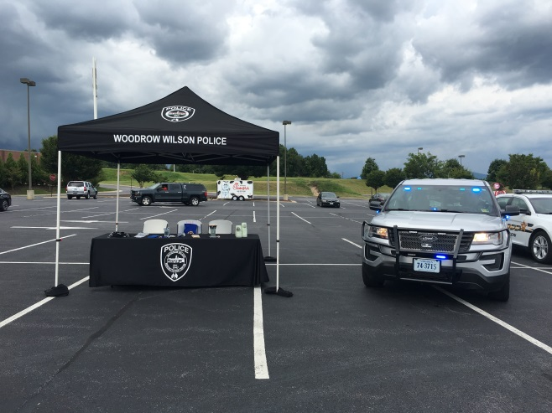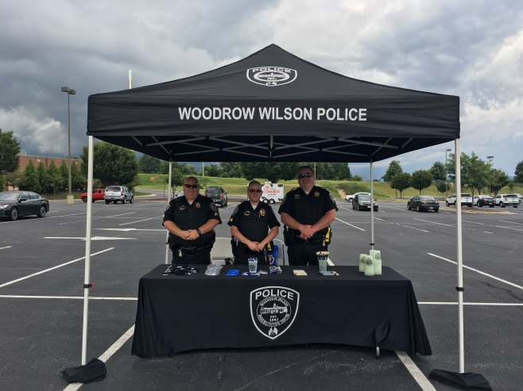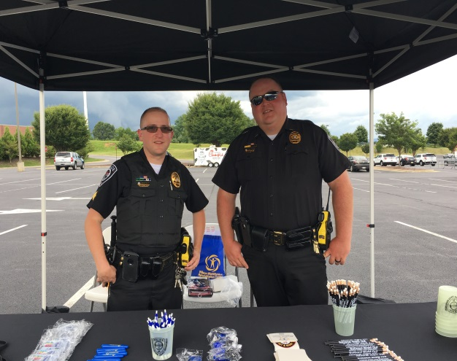

Officers participated in National Night Out sponsored by the Waynesboro Police Department and Target. Officers spoke with the public and showed department equipment.

Special Olympics Car Show October 1st, 2018

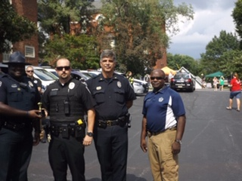

Officers participated in the 2018 Special Olympics Car show winning second place in raising money for the special Olympics.

Building Trades Class Visit and Presentation August 27, 2018

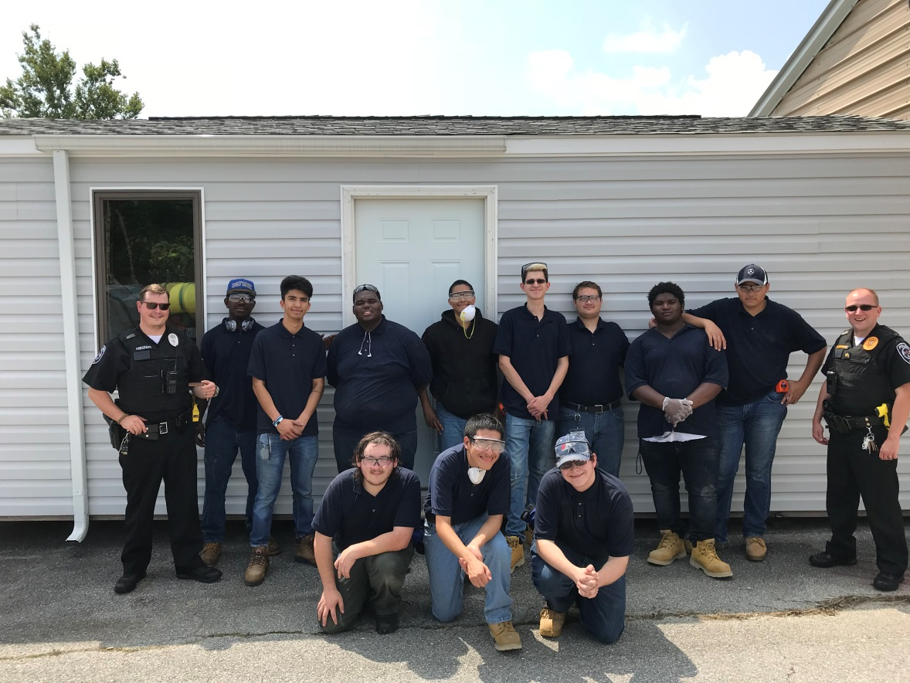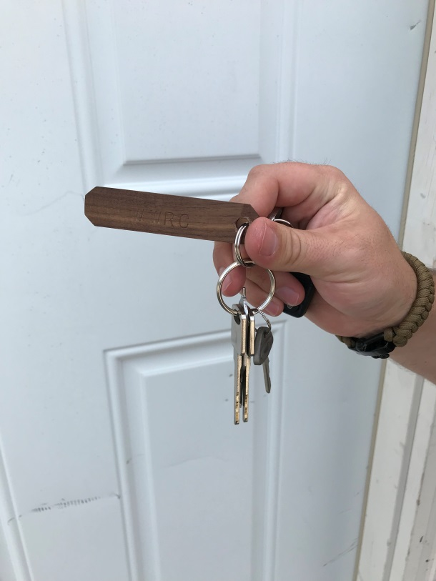

Officers visited with Building Trades Class and were presented with handmade key chains by the class.

Pre-ETS Career Day 2018

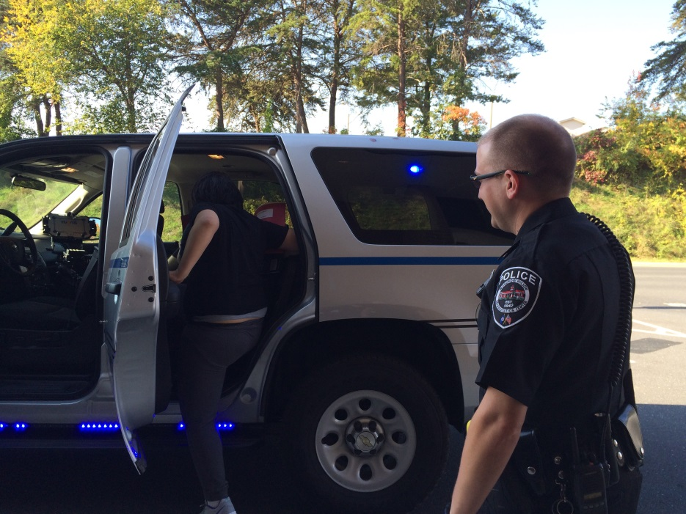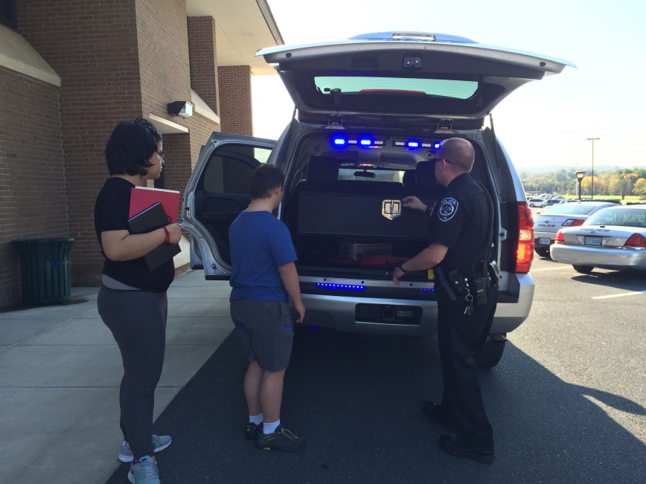

Officers worked with consumers for a career day showing aspects of police work with hands on displays.

**Organizational Chart**

Goals and Objectives

* **Goal - Develop and implement a Mission Statement and a set of core values which will serve as the foundation in developing a comprehensive group of Standard Operating Procedures for all police personnel. These will outline expectations for employees, what functions the agency performs and how we go about completing them. These will be accessible to all personnel.**

**Objectives:**

1. Review our list of current policies, assure a policy exists for each function we perform, and review content.
2. Update content to reflect current laws and best practices.
3. Arrange this information where it is easily accessible to our users and reads in a clear manner.
4. Establish the outline of Standardized Operating Procedures in a format which is consistent with State Accreditation standards

* **Goal - Continue our partnership with the citizens of our community, creating a stronger, transparent, trusting relationship by addressing quality of life concerns and improving the quality of service to our community.**

**Objectives:**

1. Continue outreach programs such as “National Night Out”, our quarterly town hall meetings for Q & A, and monthly meetings with driver’s educational classes.
2. Continue to foster a community policing presence by having an officer deployed on a bicycle at least 50 days.
3. Take a proactive approach to addressing campus violations with clients to resolve quality of life issues and concerns.
4. Officers will attempt to respond to all emergency and non-emergency response calls in a timely, yet safe manner.
5. Calls for service will be answered in a positive and helpful manner in all instances where possible.

* **Goal - Reduce Exposure to Liability**

**Objectives:**   
  
 1. Begin Accreditation Process through VLEPSC.

2. Review and update the pursuit and emergency driving policies.

3. Continue development of a training program for officers that assure that firearms qualification, emergency driving, self-defense, first aid, department policy review, arrest, detention, traffic stops, searches and seizures, and review of interview and interrogation techniques are taught and reviewed yearly.

**End of Report**