EXECUTIVE SUMMARY
During State Fiscal Year (SFY) 2022, Five hundred and thirty-three (533) explorations were performed for youth with disabilities through the PERT Program, located on the campus of Wilson Workforce and Rehabilitation Center (WWRC) and in the community. There were 503 explorations last fiscal year. The services received breakdown into these categories:

Comprehensive Evaluations and Youth in Transition | 235
Virtual Program | 190
Situation Assessments/ Manufacturing Academy | 3
Transition Academy | 7
Career Day/Career Seminar | 62
Credential week | 21
Community PERT | 15
Total explorations in SFY 2022 | 533

Many of the metrics that PERT typically presents in an Annual report will be unavailable this year as PERT was not provided with official AWARE numbers. This includes PERT Participation by AWARE Case type, Student Demographics, Medical Ancillaries Provided, and Vocational Recommendations.
Virtual PERT
Virtual PERT’s creation was in response to COVID 19. At the time, no student could attend on campus during the pre-vaccine response period.
Virtual PERT used a series of preparatory classes in work behaviors and independent living skills presented to students in their homes using internet based technology.
Virtual PERT implemented in January of 2021.
Programming included:
- Workplace Readiness Skills: building a routine, work/life balance, work relationships, and safety awareness. Virtual model does not include a vocational evaluation.
- Independent Living: kitchen safety, money handling, laundry skills, and mindfulness.
- Virtual tour: WWRC, PERT, and campus life.
Comments from our partners (school and DARS) regarding the Virtual program in satisfaction surveys:
For the first time being virtual, I think it was an awesome experience. It opened doors for him and he is more open about what he wants. He is planning on coming to campus this summer.
This program opened doors for the student and provided an opportunity to meet and form a plan of action. The student is advocating more for himself.
What an awesome program! Even in the face of COVID, A___ got the opportunity to participate virtually and learned skills that will definitely benefit him in the future.
I feel the relationship and collaboration between PERT and the public school will benefit our students tremendously.

PERT Program Satisfaction

Program satisfaction information was gathered at the PERT Advisory Council (PAC) meetings. The PERT Advisory Council is an interdisciplinary group of stakeholders composed of former PERT students, parents, Field Rehabilitation Services staff, and local educational area transition staff from all over the state of Virginia.
PAC met in person September 1, 2022. PAC monitors progress made by receiving reports from the PERT Director at the beginning of the next cycle relative to each initiative. These meetings had 20 participants representing DOE, DARS, and Local Area School Transition staff. Participants engaged in a discussion regarding the programming plans related to PERT post- COVID. For the rest of 2021- 2022, PERT will be working on a 2-week schedule, with Week 1 being a 5-Day Onsite Comprehensive Intake (capped at 14, per COVID restrictions), and Week 2 being a 2-Day Virtual Work Behaviors and Independent Living Skills Program. Also discussed was the PERT 3-year and 10-year plans. The 10-year plan includes enlarging PERT comprehensive programming from PERT’s current numbers, to 1,000 placing overall service numbers well over 1300 clients per year. The PAC members had an opportunity to provide feedback.
Satisfaction information was gathered through PERT and Center student exit interviews, report implementation meetings held in the student’s community, and surveys that accompany the student’s summary completion report.

DARS Survey Results: 36 responses total

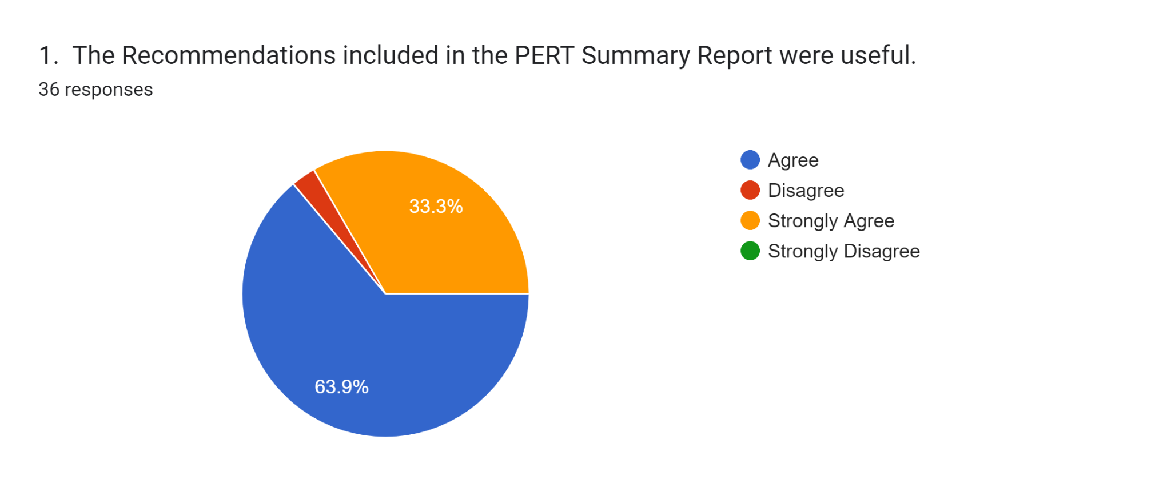
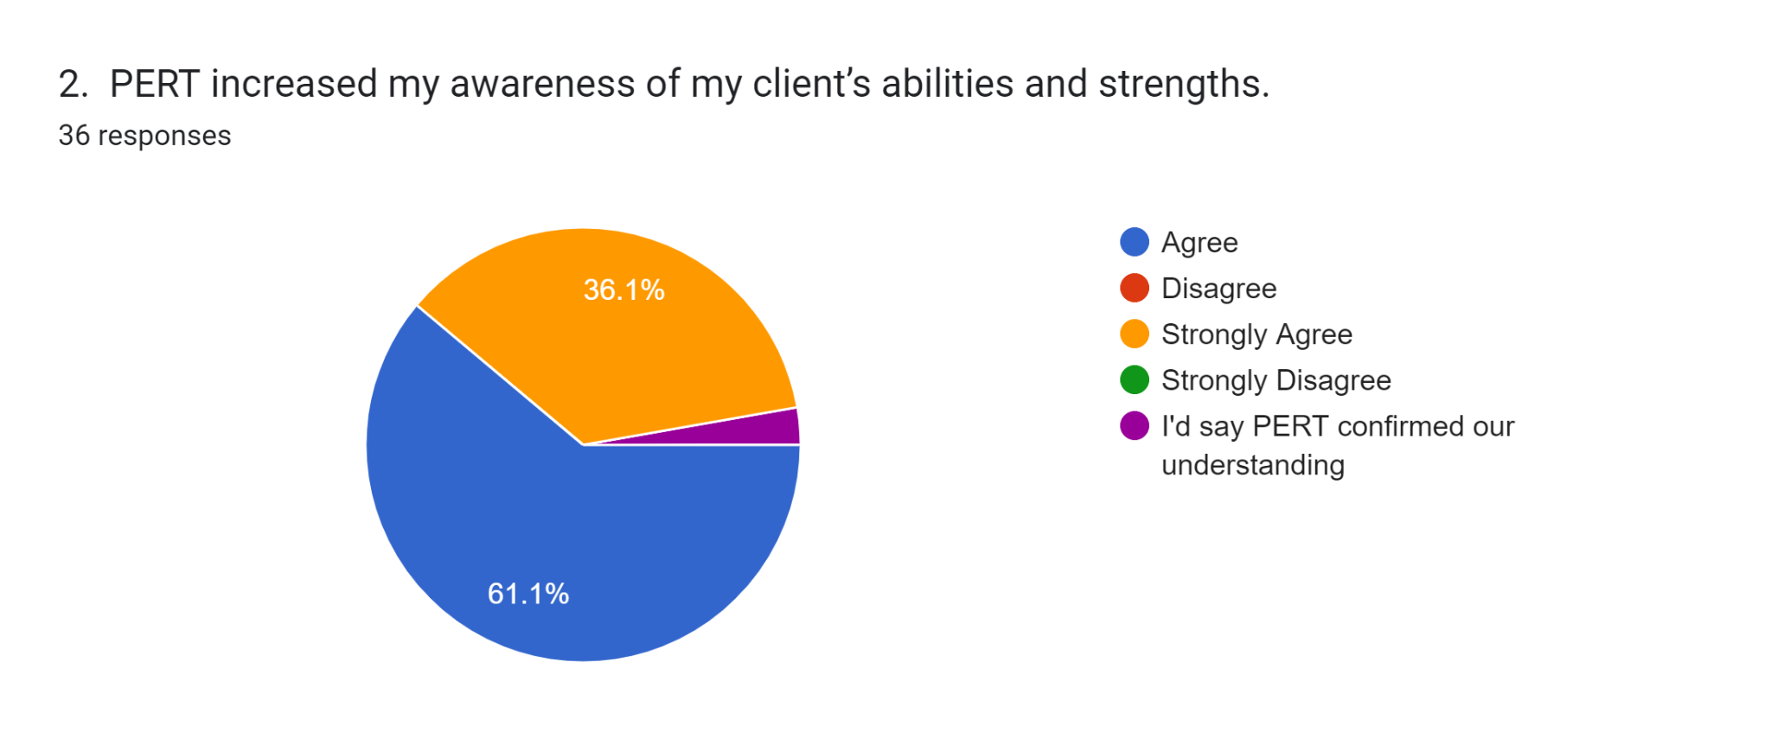

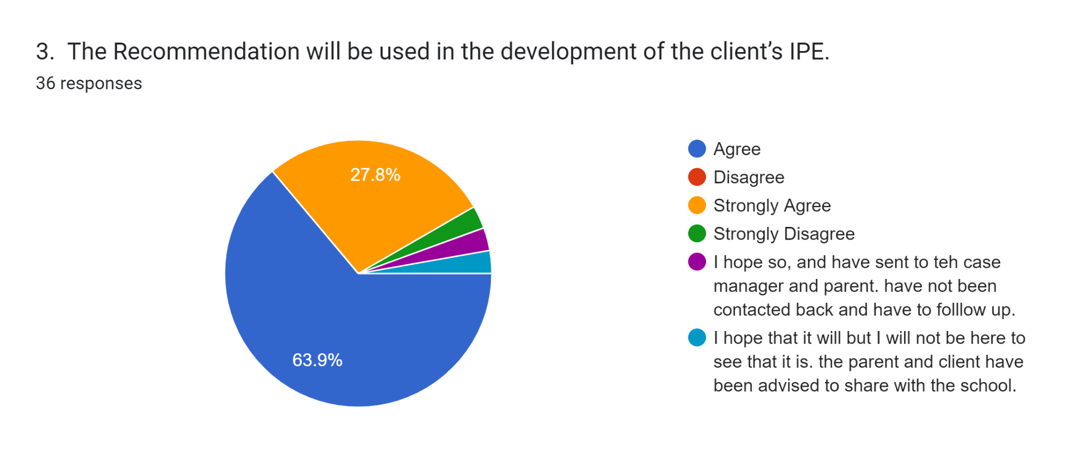
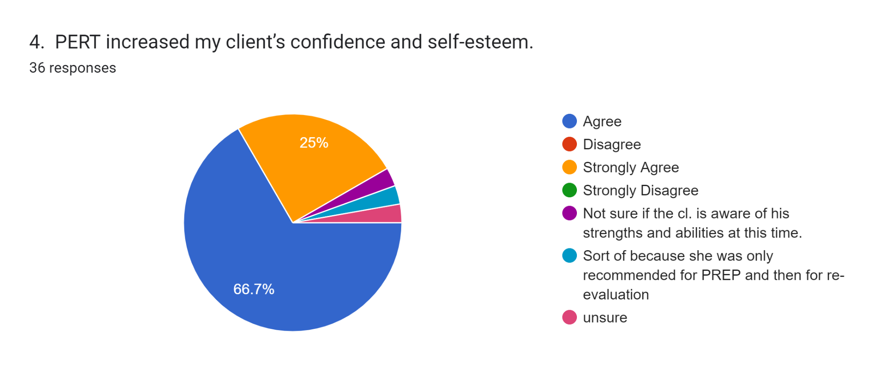

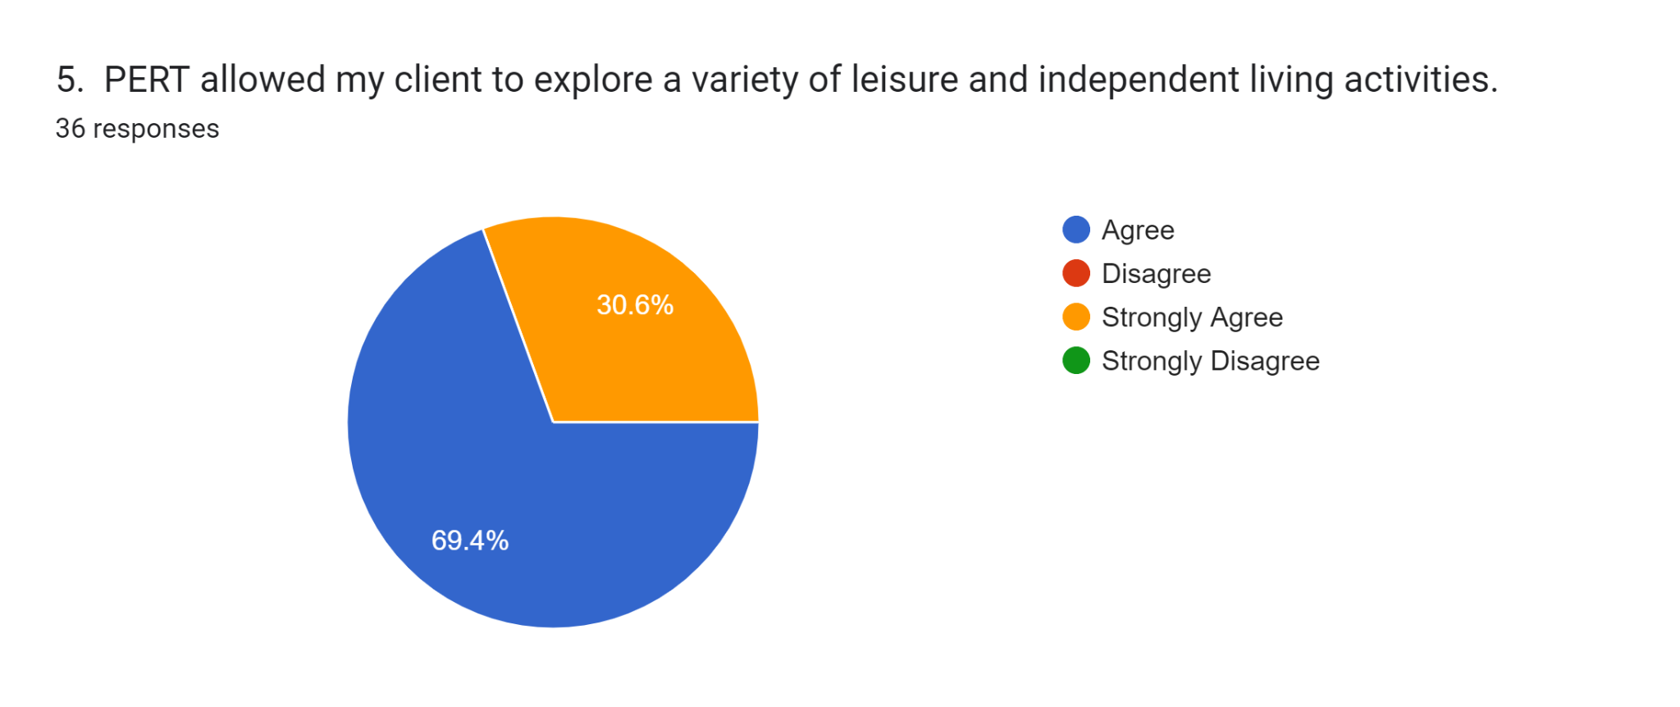
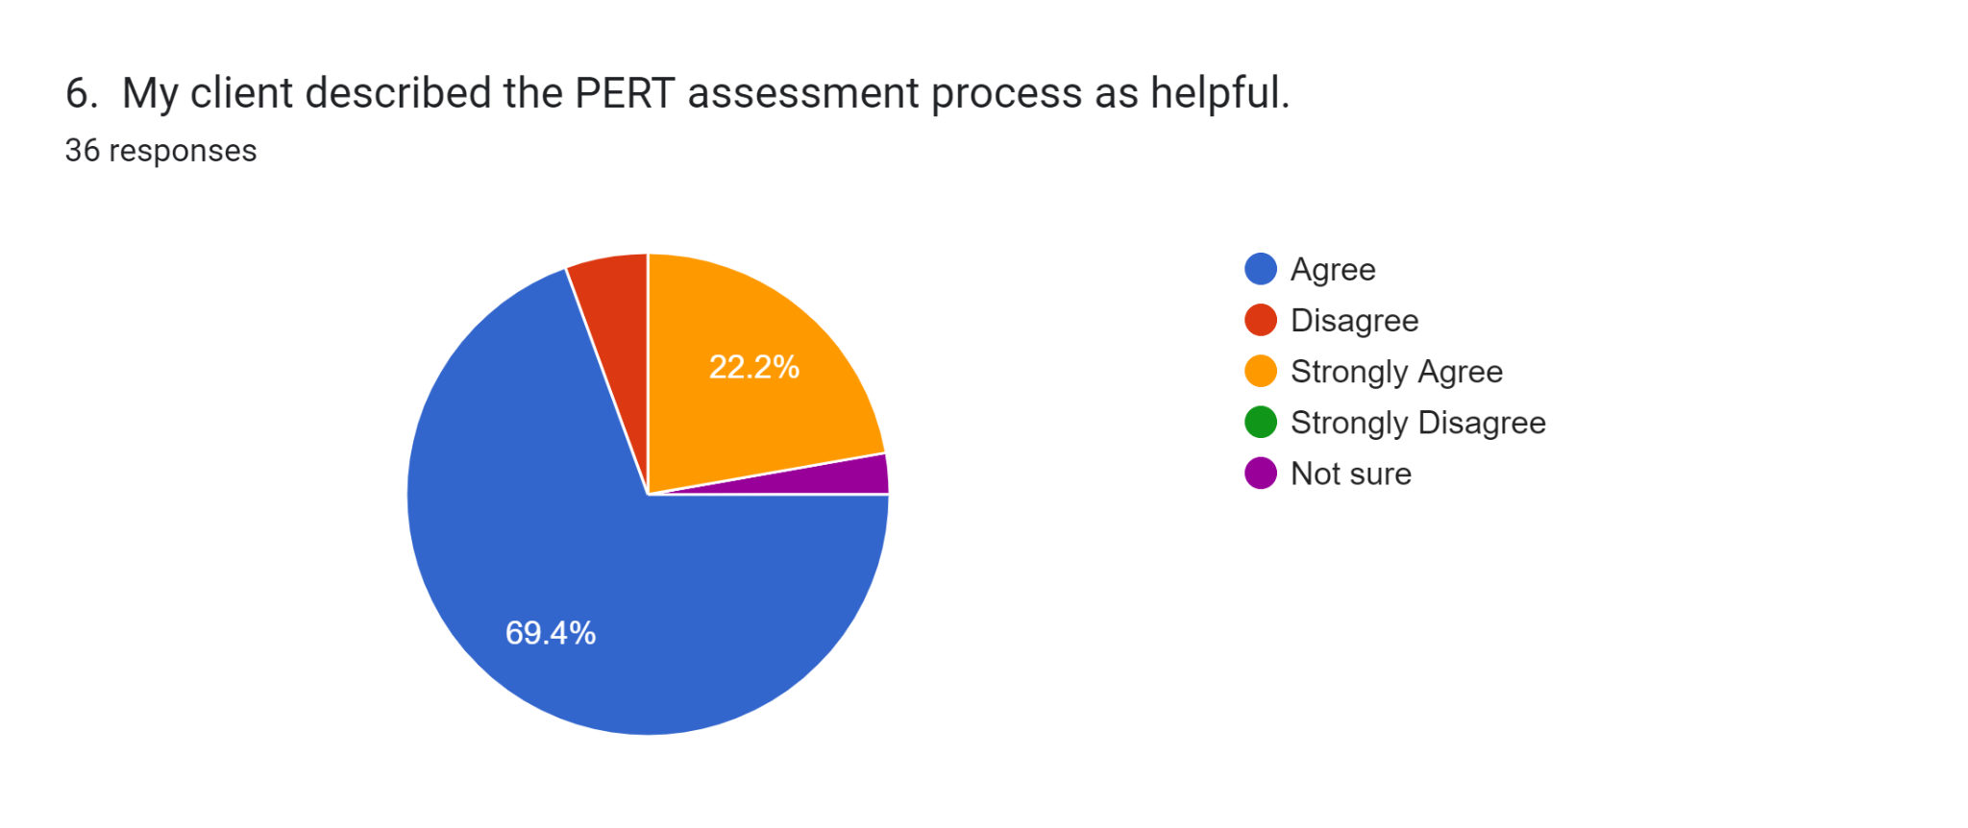
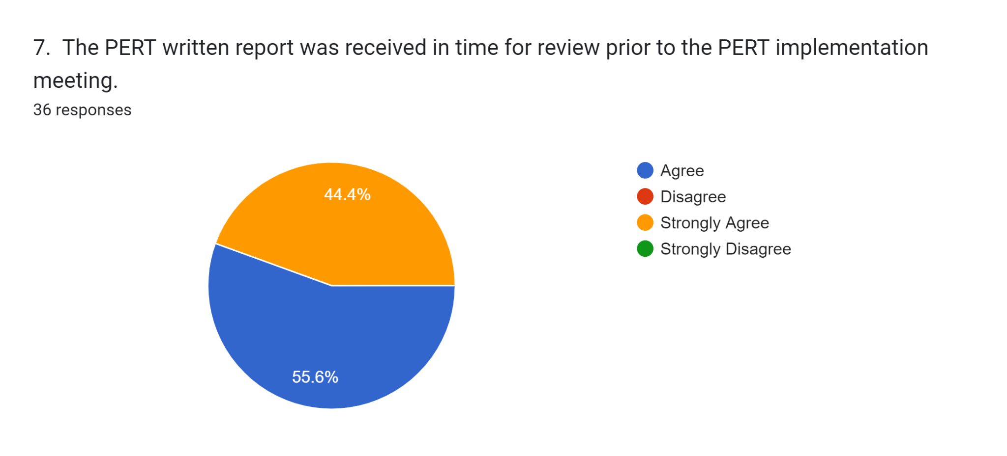
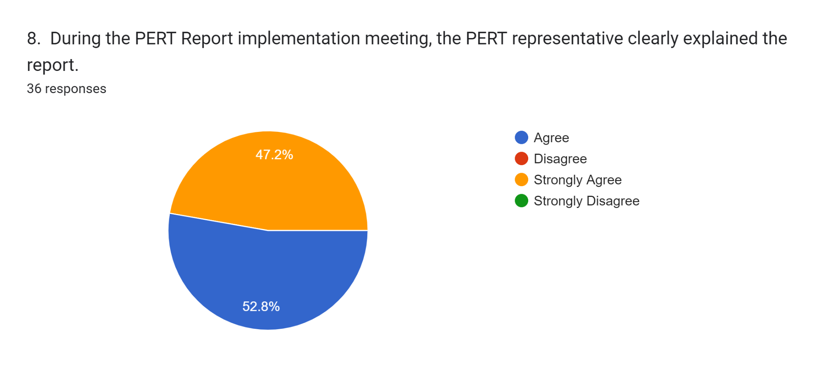
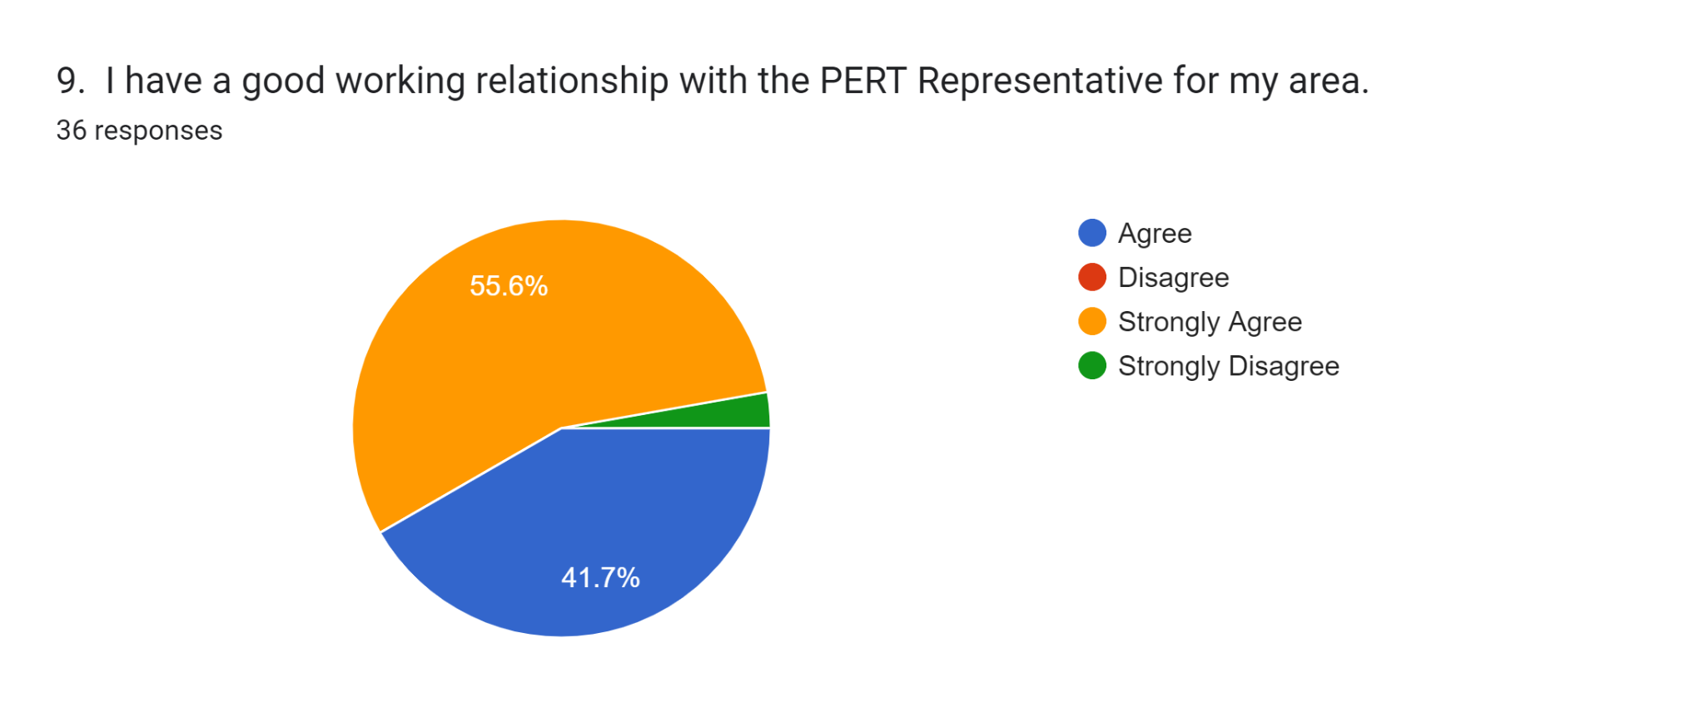
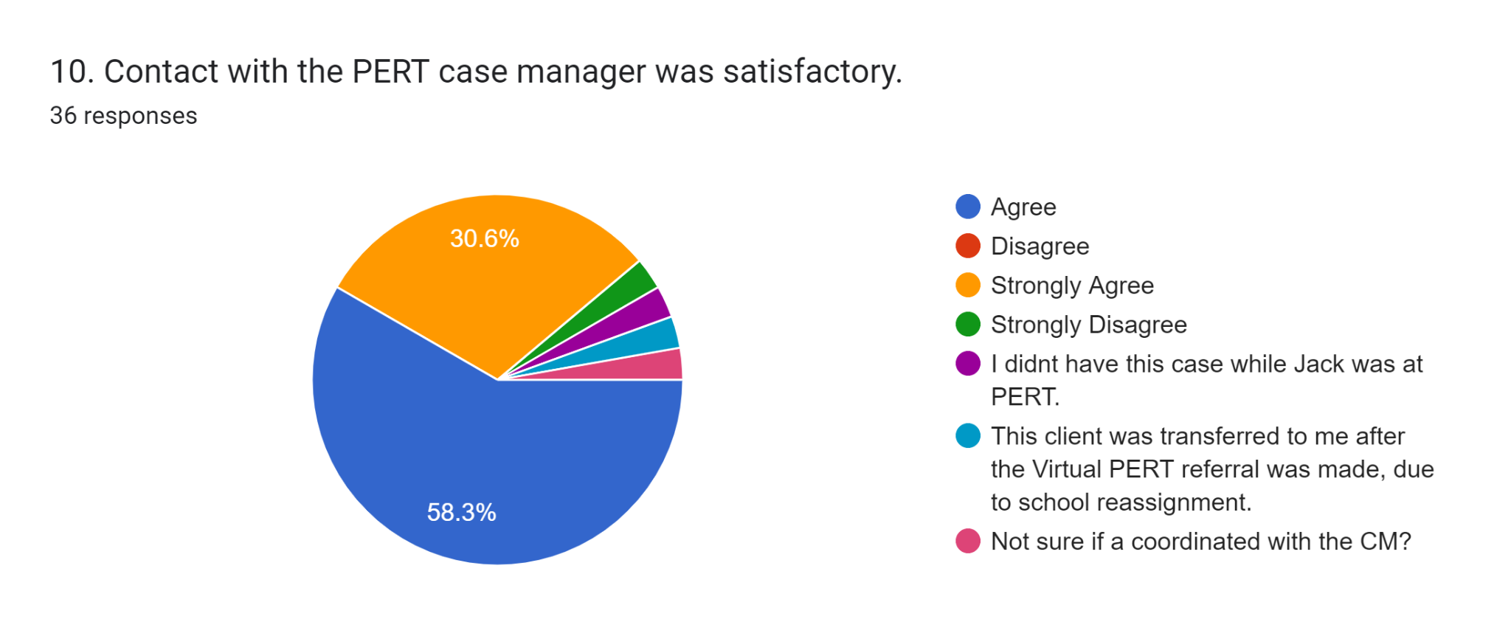

Parent Survey Results: 20 Responses

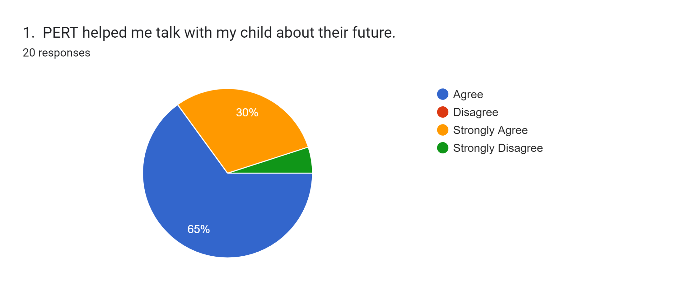
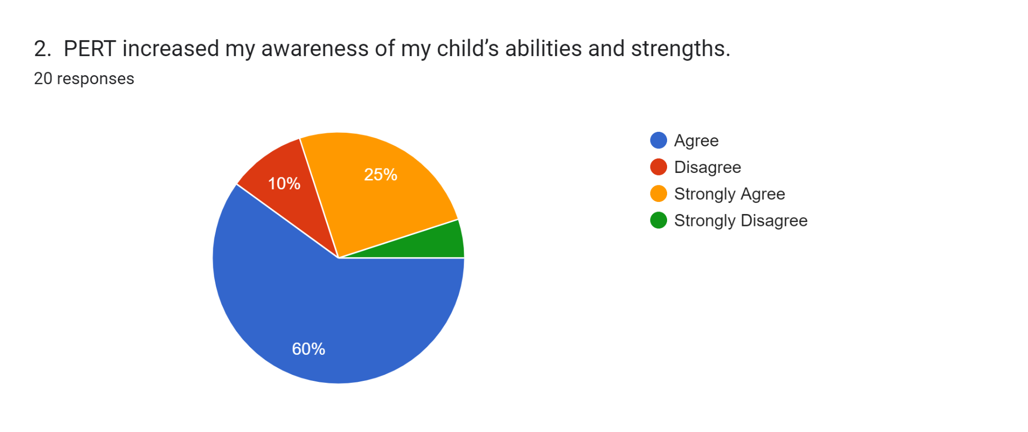
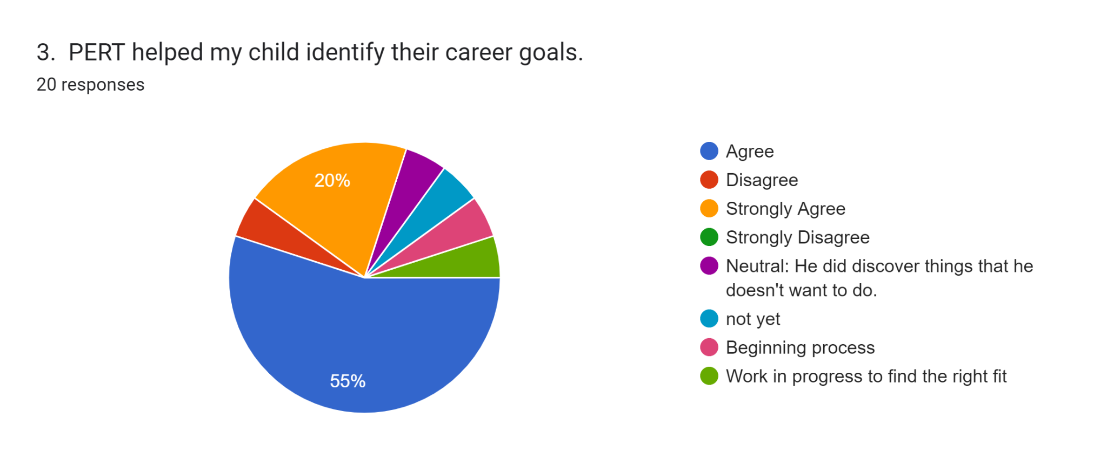
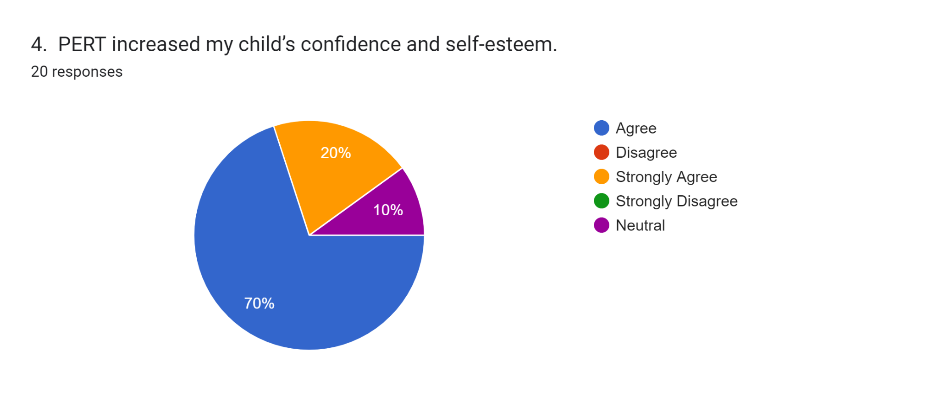
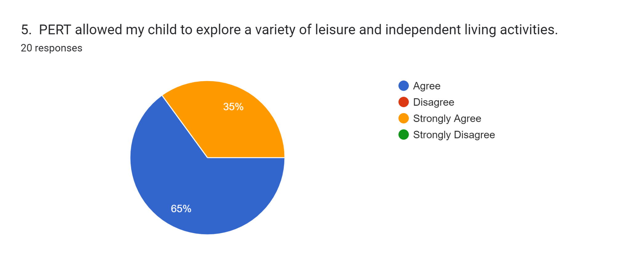
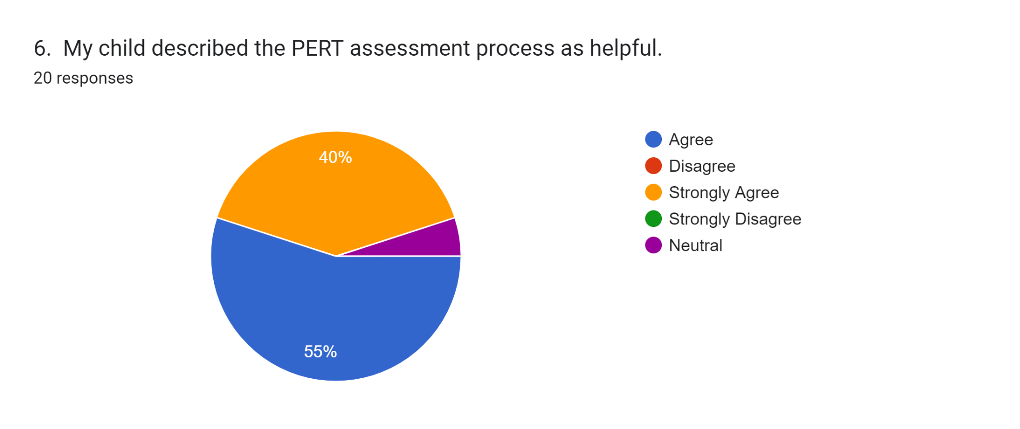

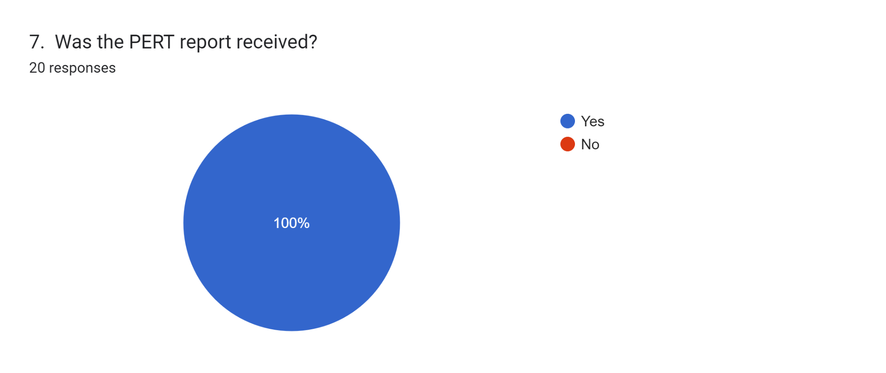
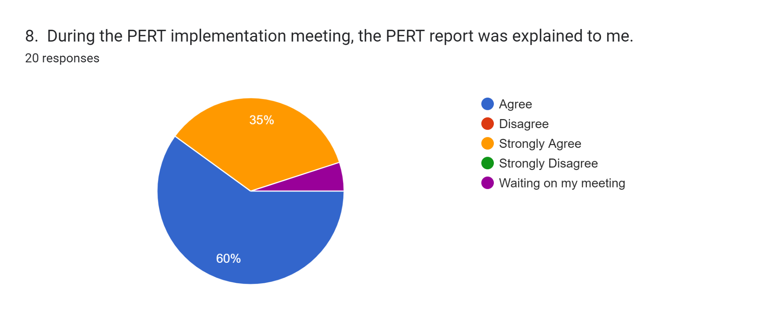
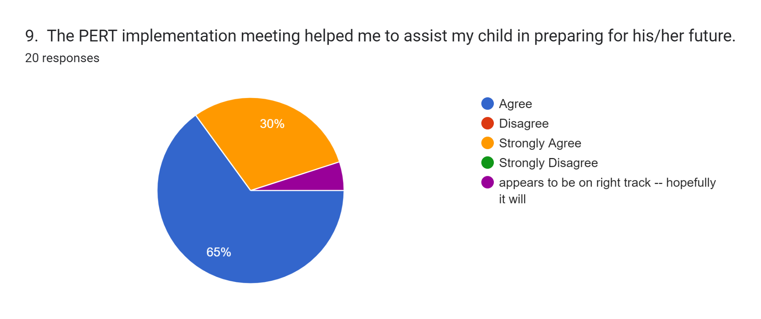
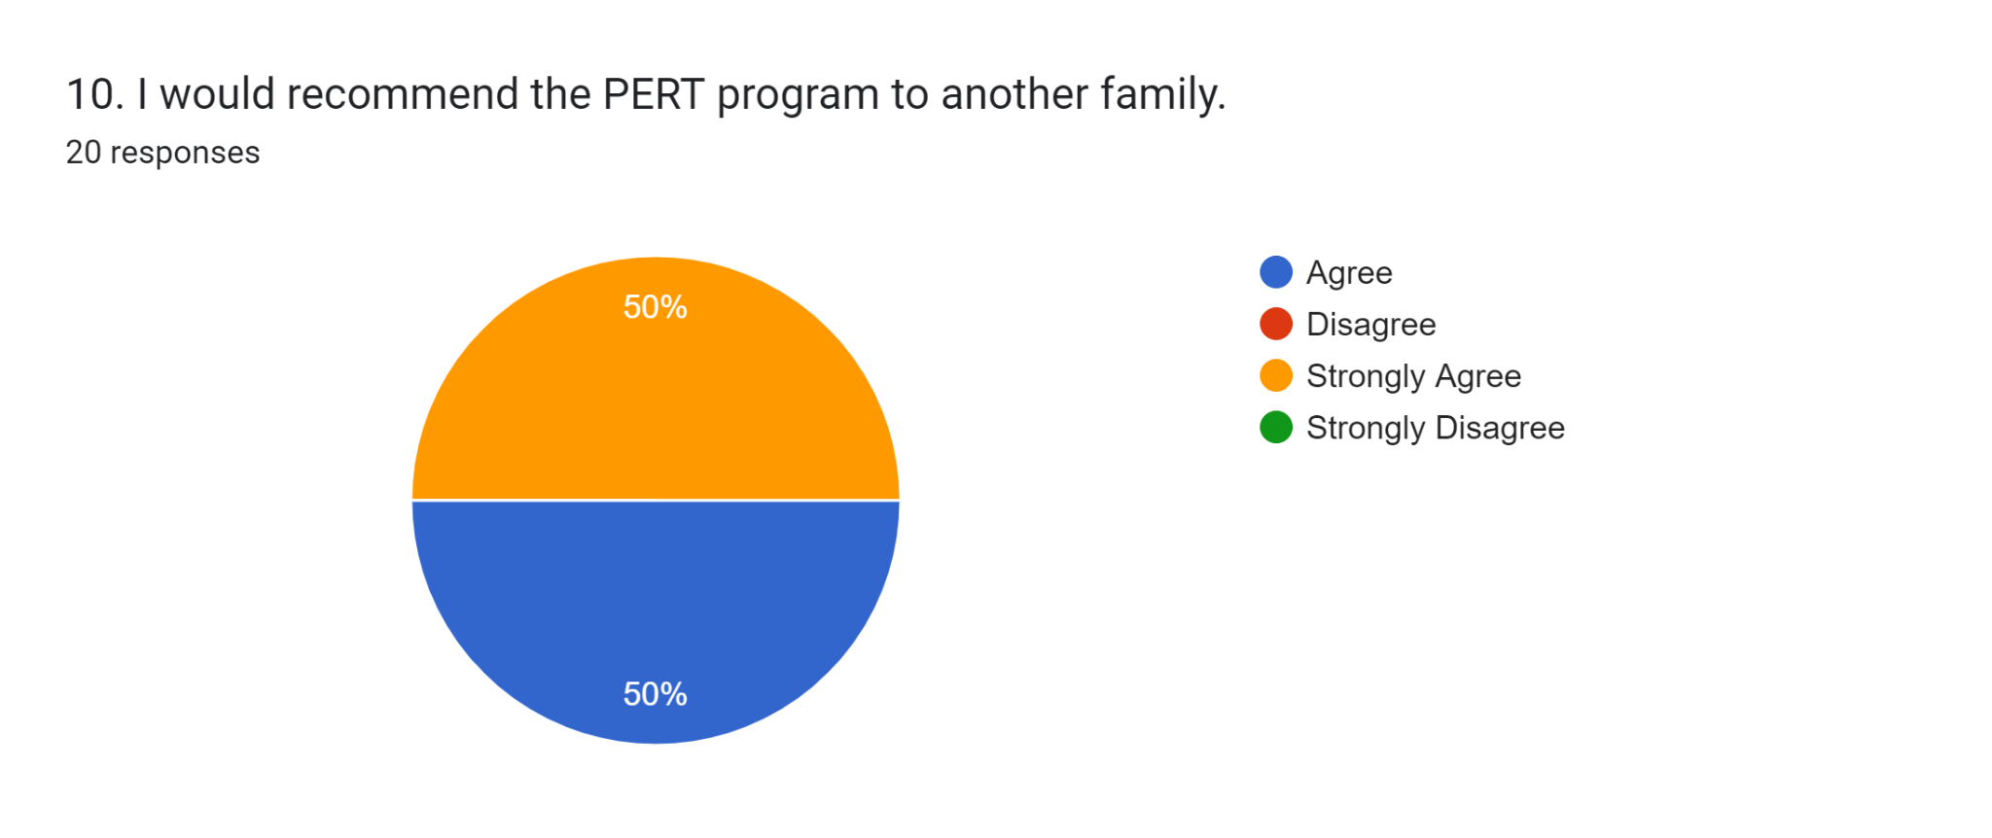

I would definitely recommend the PERT program to another family!
And I have already recommended it
Yes
I don't think this program is for Jack but I think it benefits others. Jack is a different young man. He enjoyed counselors, met a few new friends, and Mrs. Owens was very thoughtful, kind, helpful, and caring!! She is an asset to The Pert Program!
My son Jakeem was extremely happy with his experience is looking forward to coming back

School Survey results: 23 responses

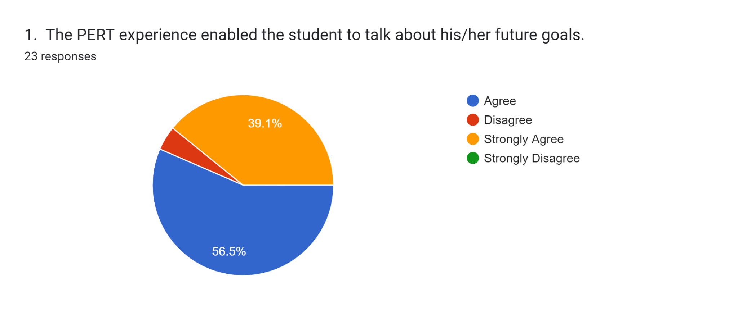
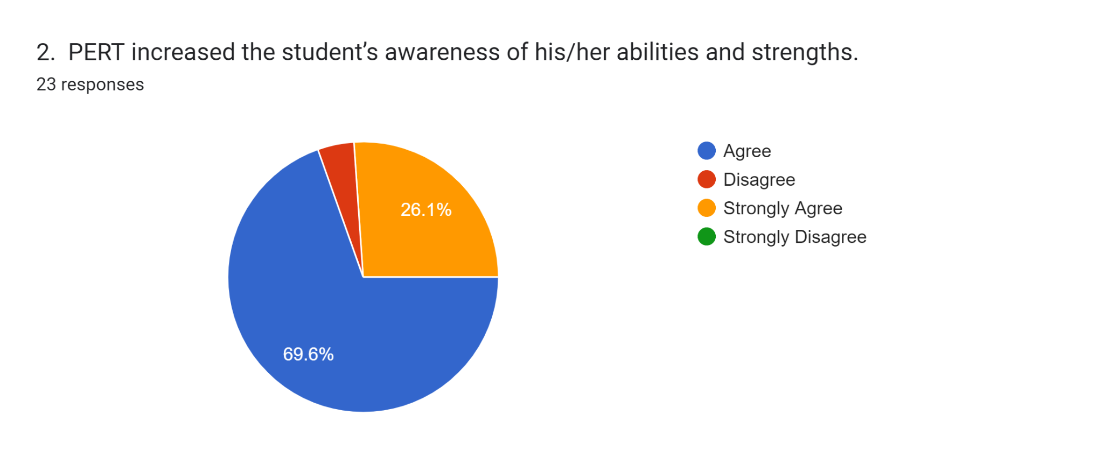

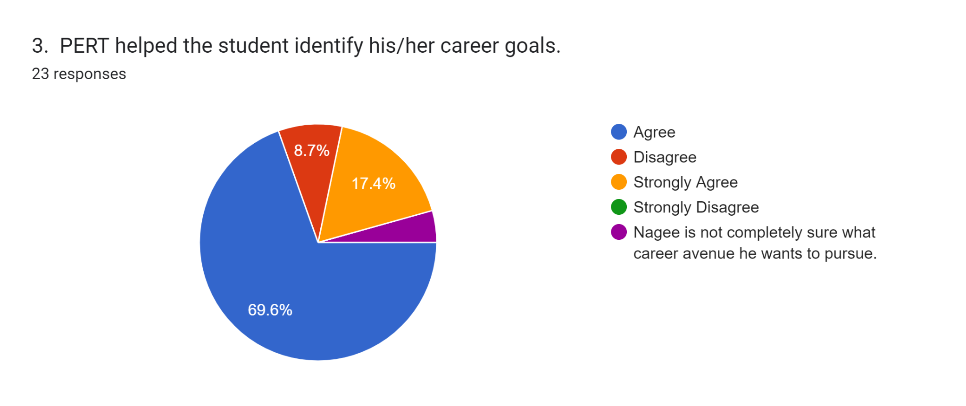
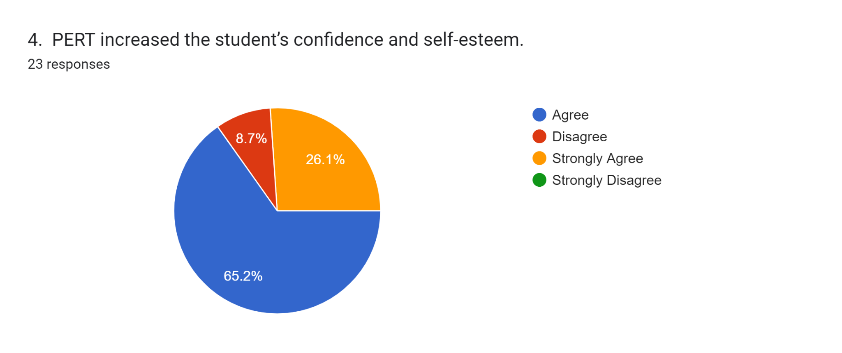
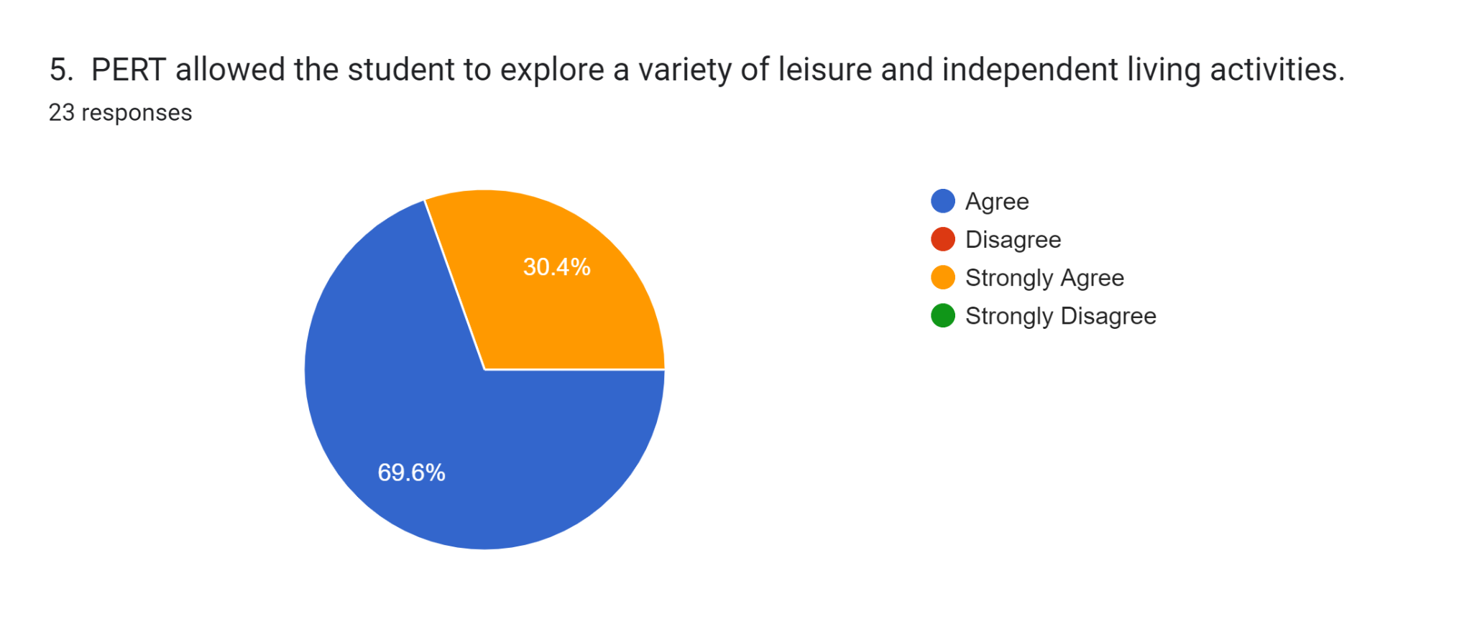
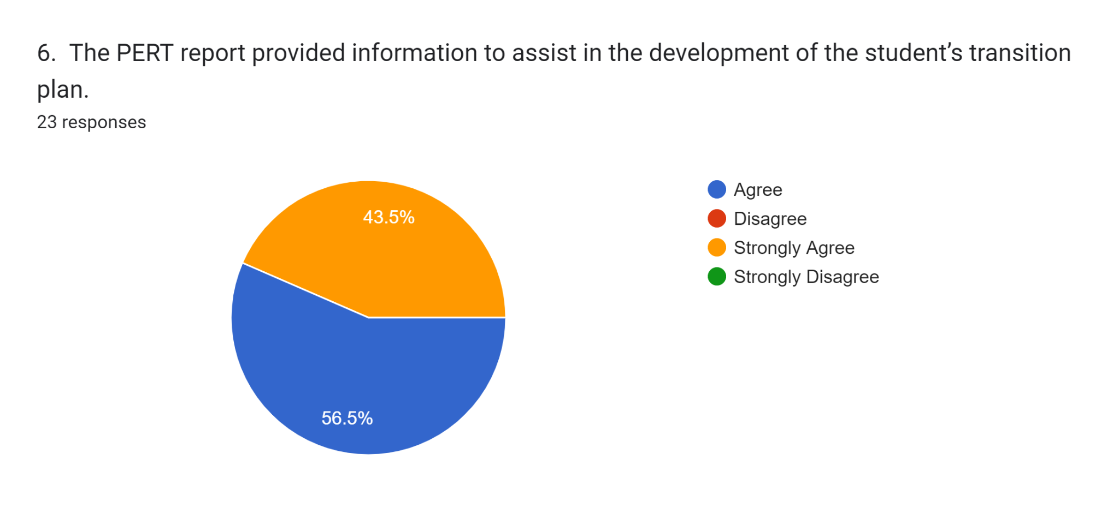
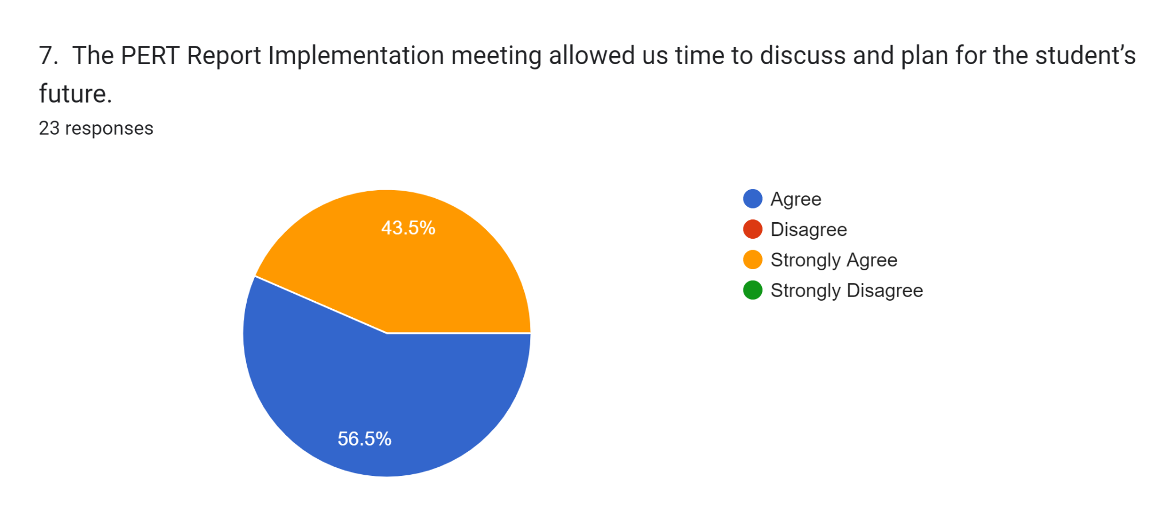

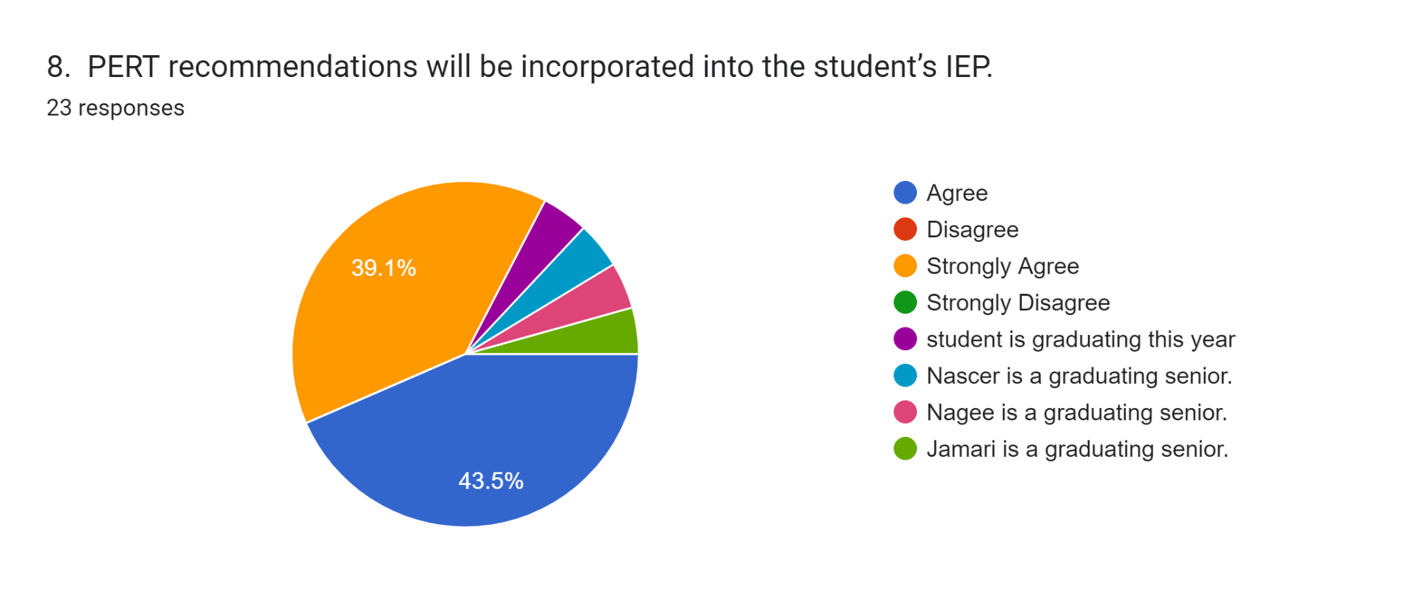
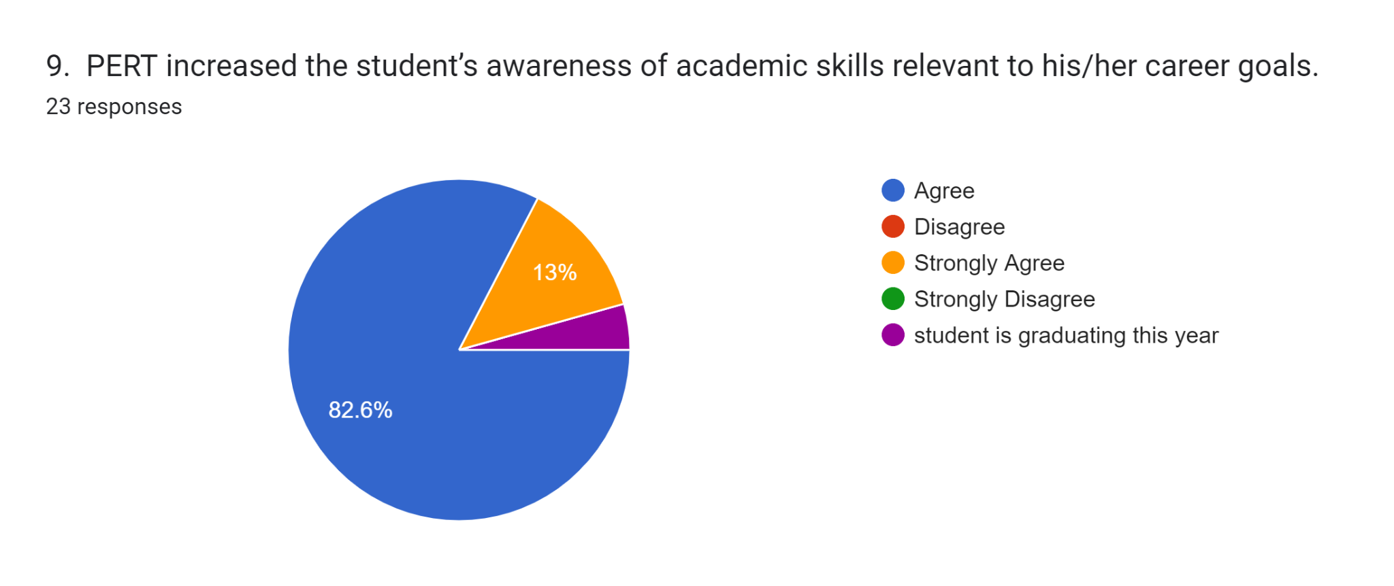
10. Any additional comments:
The PERT program and WWRC are so supportive and very comprehensive on the approaches they use on students. I think PERT is a great opportunity for students to get the assessments that will help them with their Post-Secondary Goals.
I want to thank the PERT staff for always being very supportive with the needs of our Special Ed. population in Font Royal and helping them get trained and assessed.
I am glad Marcus had the opportunity to attend PERT!!!!
The PERT experience was truly a living experience for Joshua; he learned a lot, especially independent living skills, which he needs to incorporate in his daily living.
This was a great experience for CJ.
Ethan did a great job at PERT and definitely has a lot of options to return to
Our experience with DARS has always been exceptional!
I appreciate Kati taking the time to come up and make sure everyone understands the reports and how they impact the students and families futures. Our experience with DARS has always been excellent.

Staffing in SFY22

Positions vacated:
PERT Team Leader.
PERT Residential Activity Specialist (2)
PERT Rehabilitation Counselor Positions (2)
PERT Therapist I
PERT Program Support Field
Multiple PERT Residential Wage Positions
Multiple PERT Independent Living Instructor positions
PERT Career Lab instructor moved to Counseling position

Positions hired:
PERT Team Leader
PERT Residential Activity Specialist (2)
PERT Rehabilitation Counselor Positions (2)
PERT Therapist I (defunded)
PERT Program Support Field
PERT Residential Wage Positions (hired 3)
Multiple PERT Independent Living Instructor positions (hired 2)

PERT Residential Activity Specialists transferred to PERT from closing of Rothrock Hall (2)
PERT Career Lab Instructor still in recruit

Summer Assessment
This service was provided to fifteen students in Fairfax.

The students are referred to the PERT program, and the selection team determines that the students may not be ready to attend Wilson Workforce and Rehabilitation Center (WWRC) residential setting for a 5 day Initial Evaluation Program. PERT staff traveled to the local region to provide independent living exploration services with a local Vocational Evaluator, and a contracted Job Coach through DARS. This community effort provides two days of vocational assessment. The program consists of interest inventories, situational assessment at the and a community work experience based upon their interests; two days of independent living assessment, developing a budget for real life situations game, cooking, kitchen safety, medication management, hygiene, self-esteem, problem-solving and hygiene assessments. The program may act as a screener for the potential of additional services on-site at WWRC.

Tours

PERT toured 636 parents and students this Fiscal Year.

PERT Trainings this fiscal year
PERT trained 284 new team members this Fiscal year in the Hampton DARs office, three trainings at WWRC, 2 virtual sessions and a 60 person training for the DARS Transition Team.
PERT Field staff provided 75 consultations with DARS and School staff.
PERT was a planner and participant in the Region 2 DARS/DOE Transition Training coordinated by Martin Kurylowski.
PERT also provided an Independent Living Assessment Training to 18 DARS, Special education and Transition staff in the West Central Region so they could implement these assessments in their local educational areas.

